HYSTERECTOMY & OOPHORECTOMY SURGERY

HYSTERECTOMY & OOPHORECTOMY SURGERY
Hysterectomy is commonly used to refer to removing all internal reproductive organs: the cervix, uterus, fallopian tubes and ovaries, although technically “hysterectomy” only means removal of the uterus.
Removal of the vagina (vaginectomy) is not a required part of hysterectomy or other genital surgeries (metoidioplasty and phalloplasty), but if you are planning to get a vaginectomy, hysterectomy will be performed in advance or at the same time.
If the cervix is removed, you no longer need to get monitoring pap smears.
Some people choose to leave one or both ovaries in the hope that they can function as internal estrogen hormone production when someone chooses to stop taking testosterone or loses access to testosterone.
Long term, you need to have either testosterone or estrogen in order to maintain bone density and for energy and mood.
Some people choose to leave ovaries in order to retain material to genetically reproduce with later.
There is no known reason to get a hysterectomy (removal of the uterus, sometimes also with removal of the fallopian tubes and/ or ovaries) unless we want one or are experiencing another medical problem.
Testosterone does not increase our risk of cancer in these parts, or other problems with these parts.
Many people experience pain after starting T due to cramping in the uterus.
Sometimes it is all the time, sometimes it continues monthly without any bleeding, and sometimes it is only after orgasm.
These problems don’t happen to everyone, but are common issues that we may have with our uterus after starting T.
Some pain and cramping can be normal and expected with using testosterone.
Pain that interferes with our life, such as by making it difficult to sleep or go to work, could be a sign of a serious medical problem and should be discussed with our medical provider.
While there are many things to try to help make these issues go away, some of us choose to get a hysterectomy to solve them.
Many of us choose to have a hysterectomy due to discomfort and anxiety from simply having a uterus.
If we are not interested in carrying children, and are uncomfortable because we have these body parts, then hysterectomy can be a good choice to help reduce our discomfort.

Anatomy

Hysterectomy Types
Hysterectomy procedures remove the uterus from our bodies.
Depending on our surgeon and goals, our procedure may also remove the cervix, fallopian tube(s), and ovary(ies).
They can also include different types of incisions along our belly and internally.
Hysterectomy terms we may hear:
- Partial (hysto)
- Total (hysto)
- Radical (hysto)
- Laparoscopic
- Abdominal
- Oophorectomy
Salpingo-oophorectomy includes removal of the:
- Fallopian tubes
- One or both ovaries
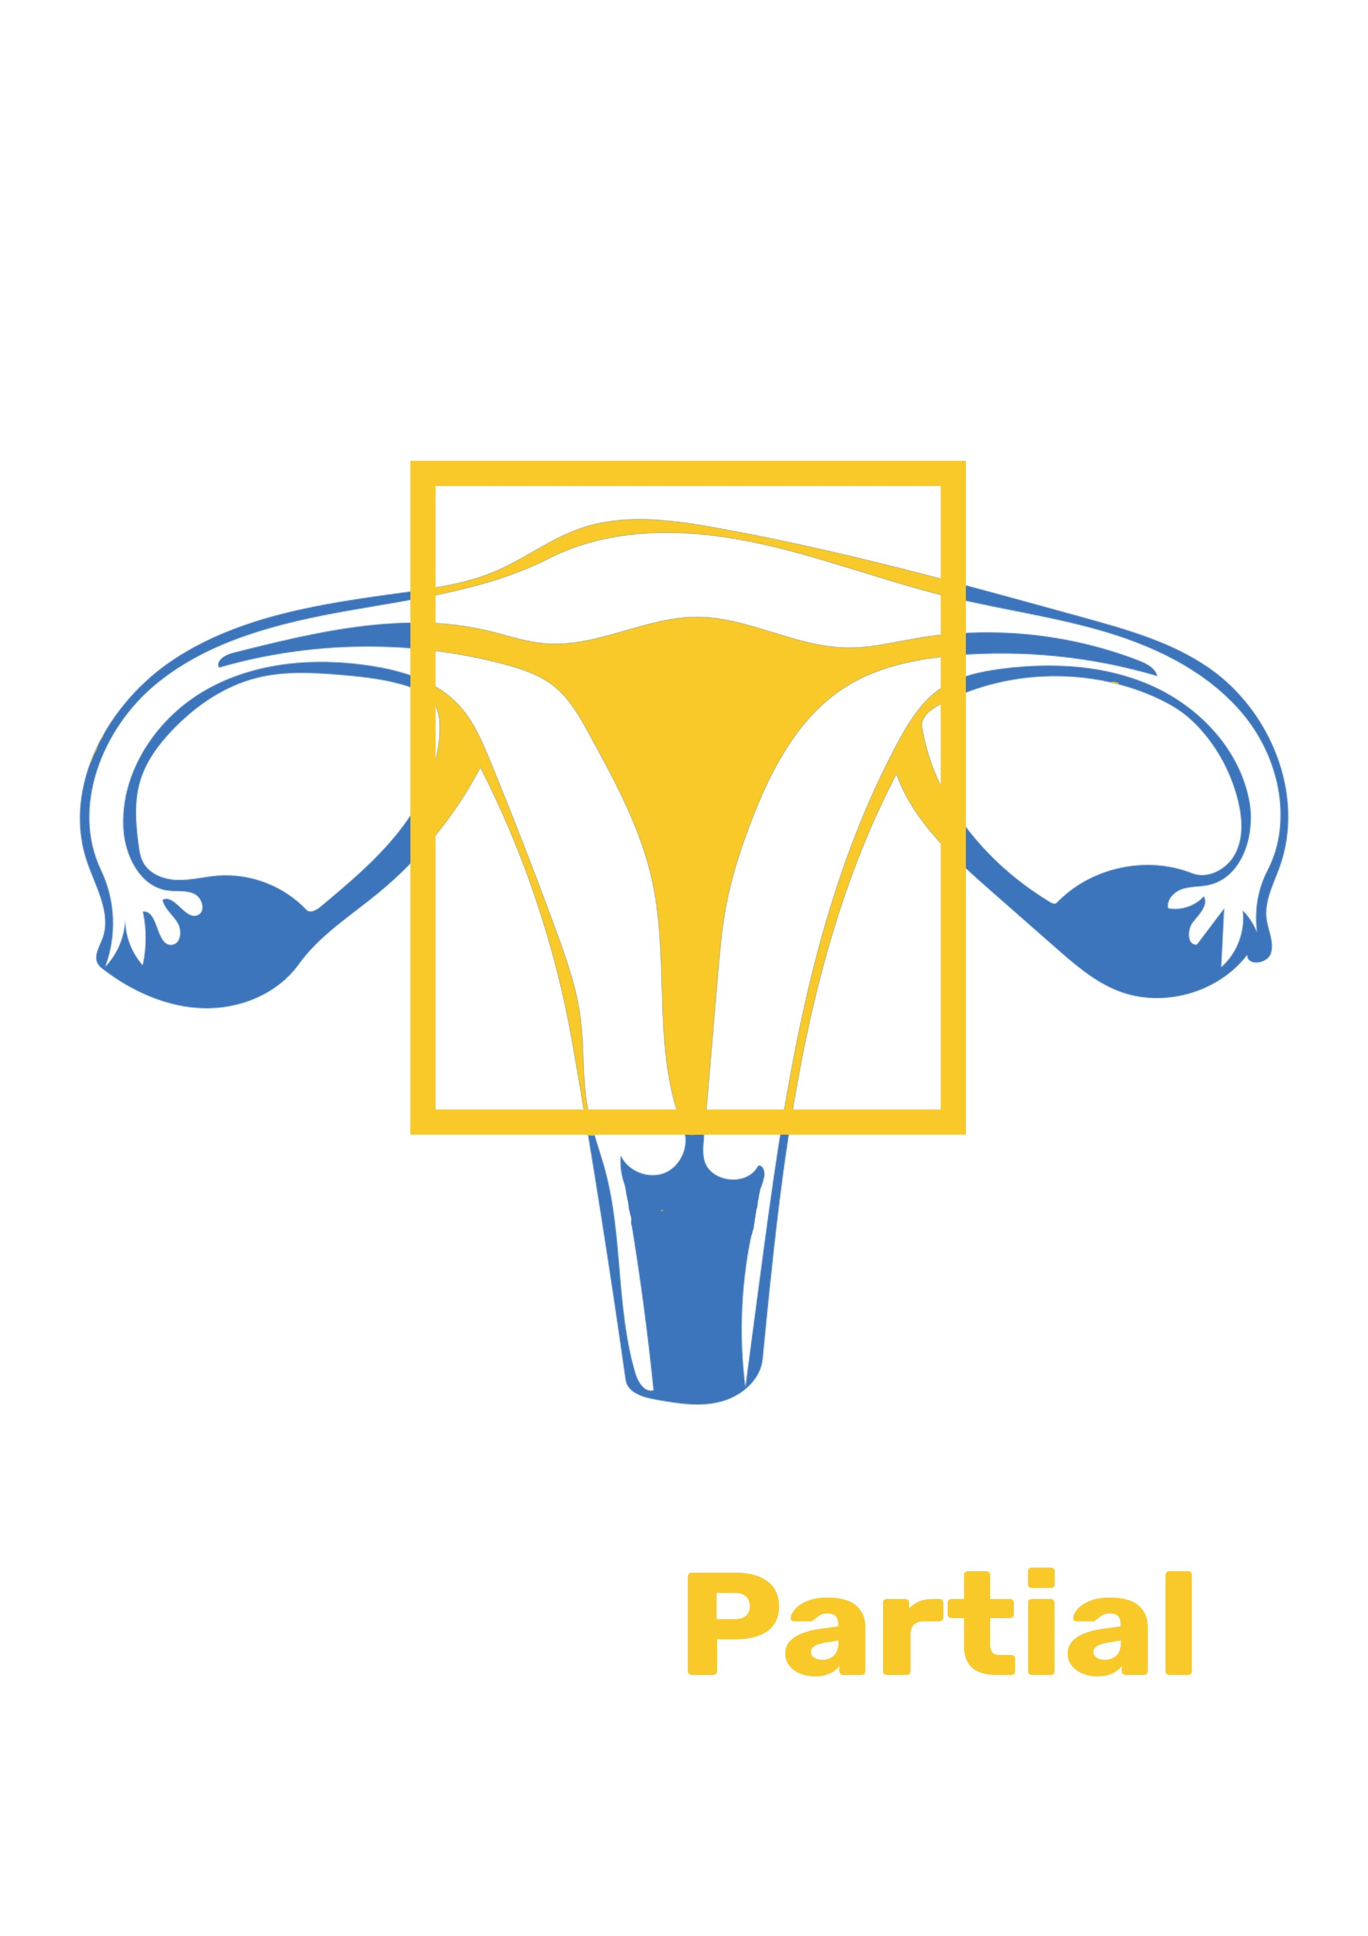
1 -
- removal of the uterus
Partial Hysterectomy includes removal of the:
- Uterus
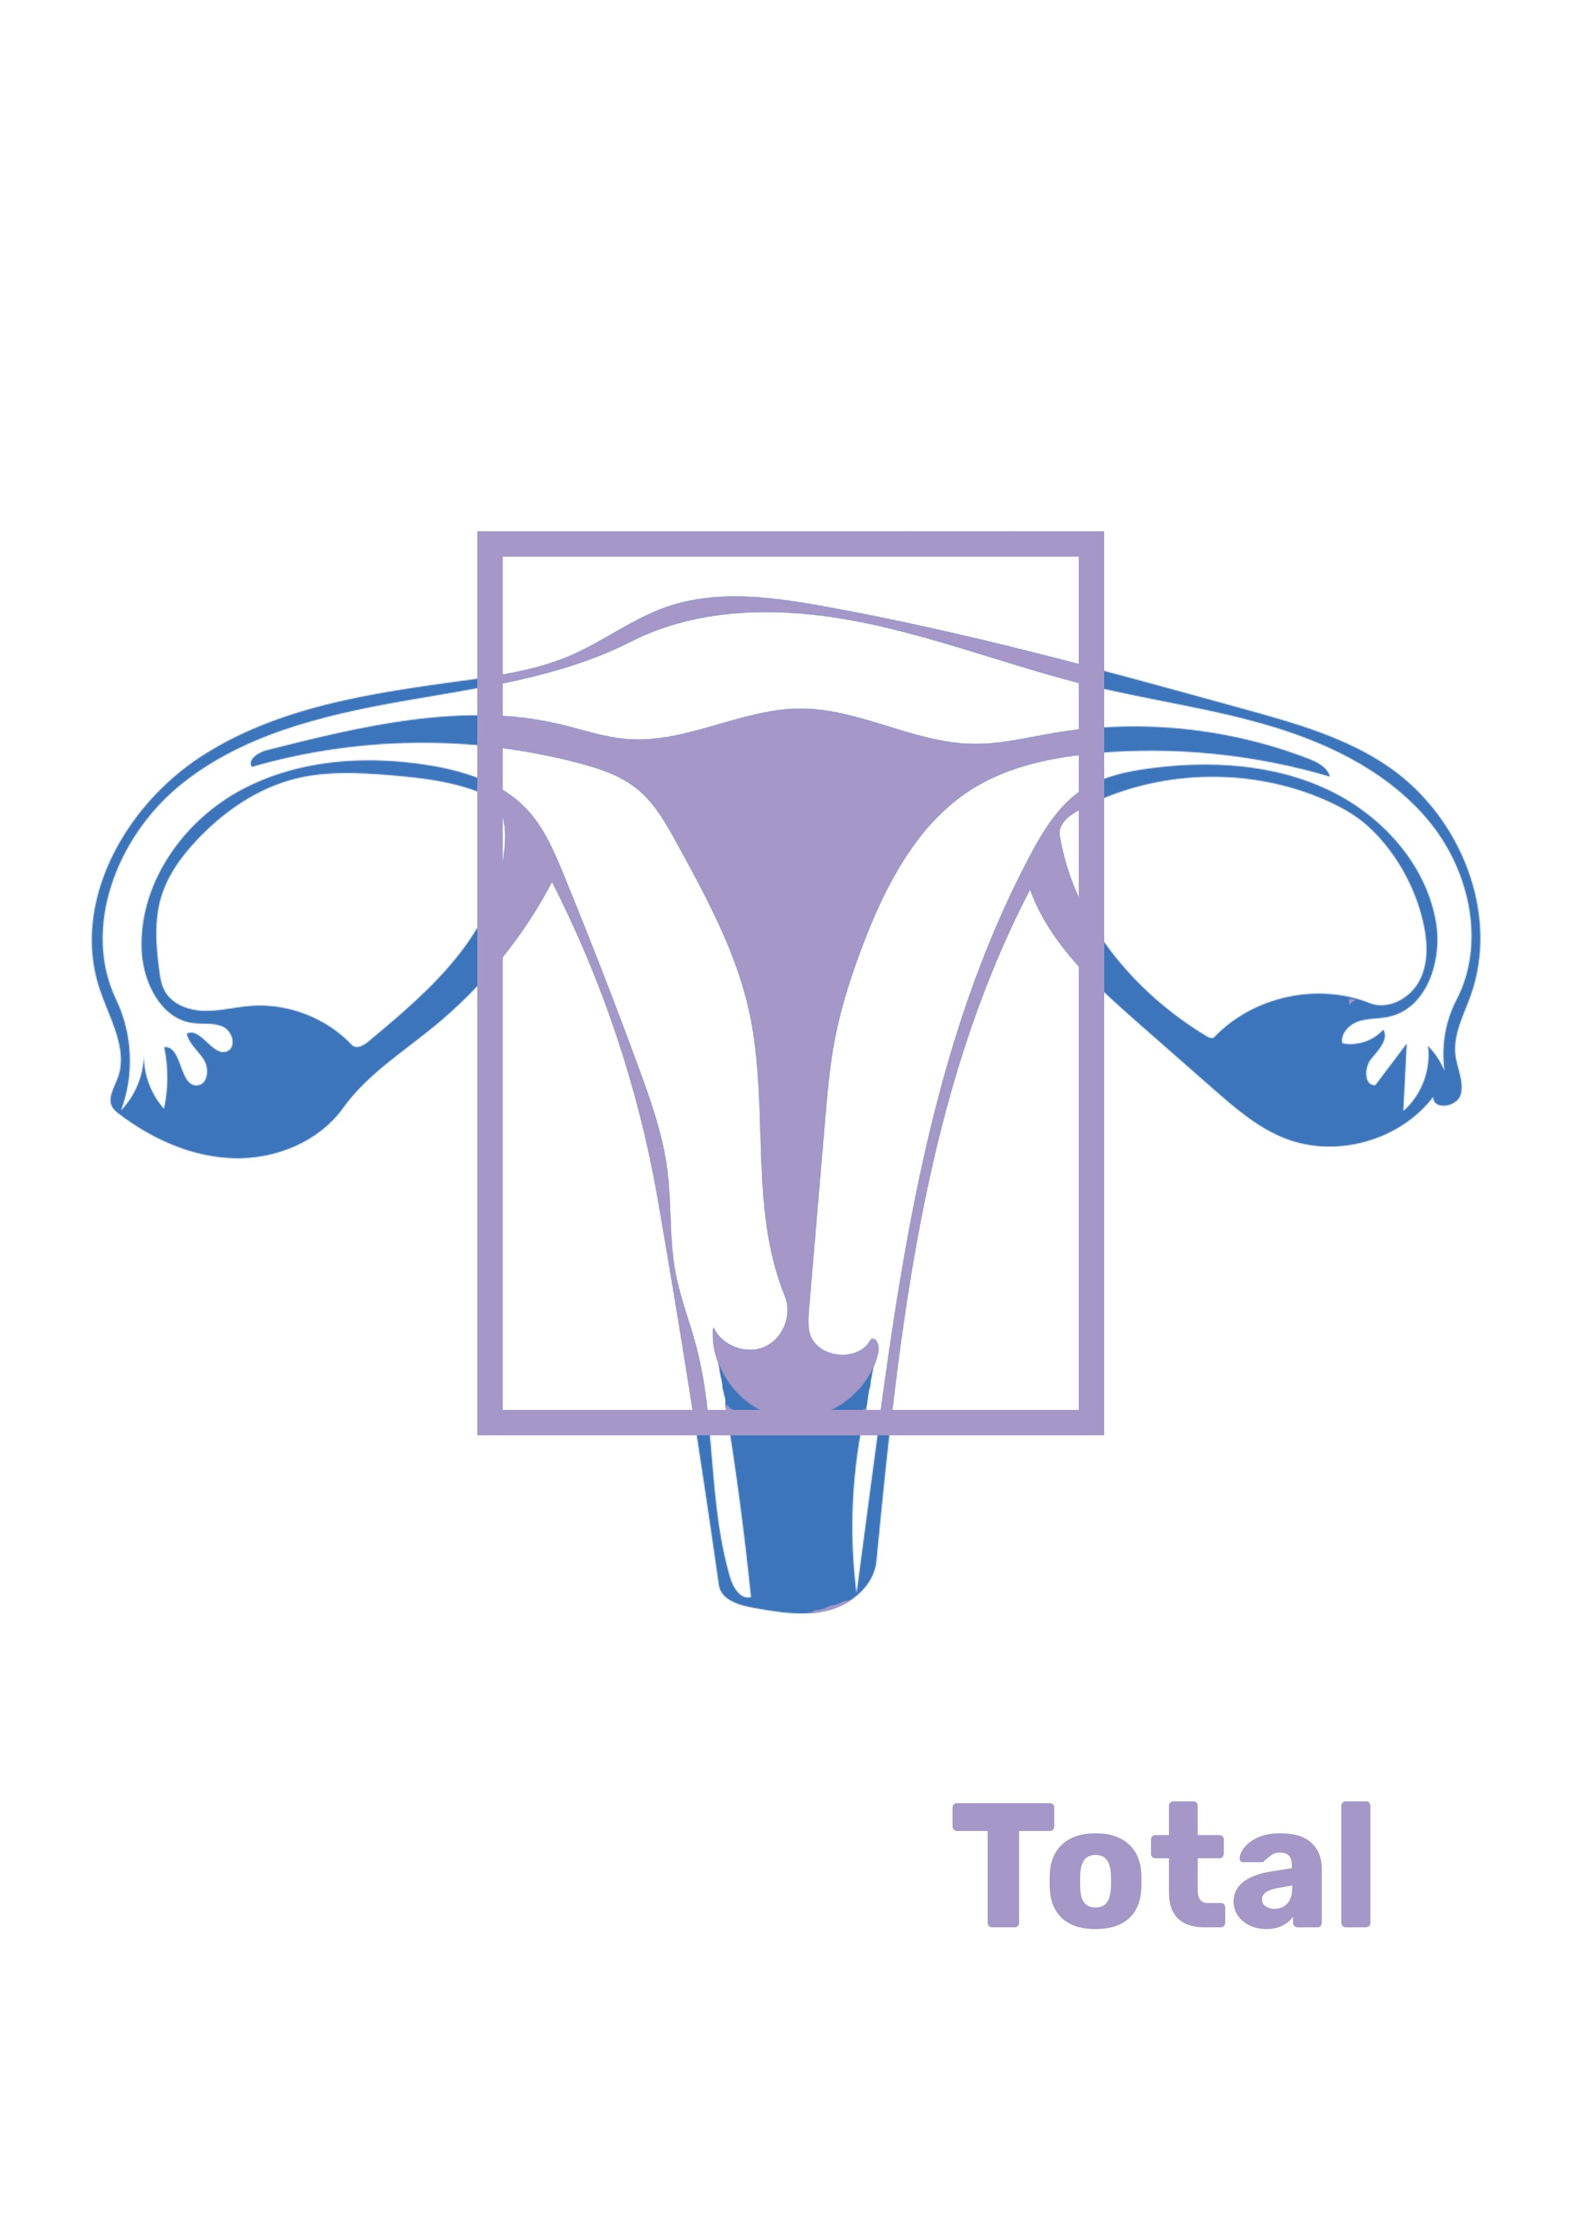
2 -
- removal of the uterus and cervix
Total Hysterectomy includes removal of the:
- Uterus
- Cervix
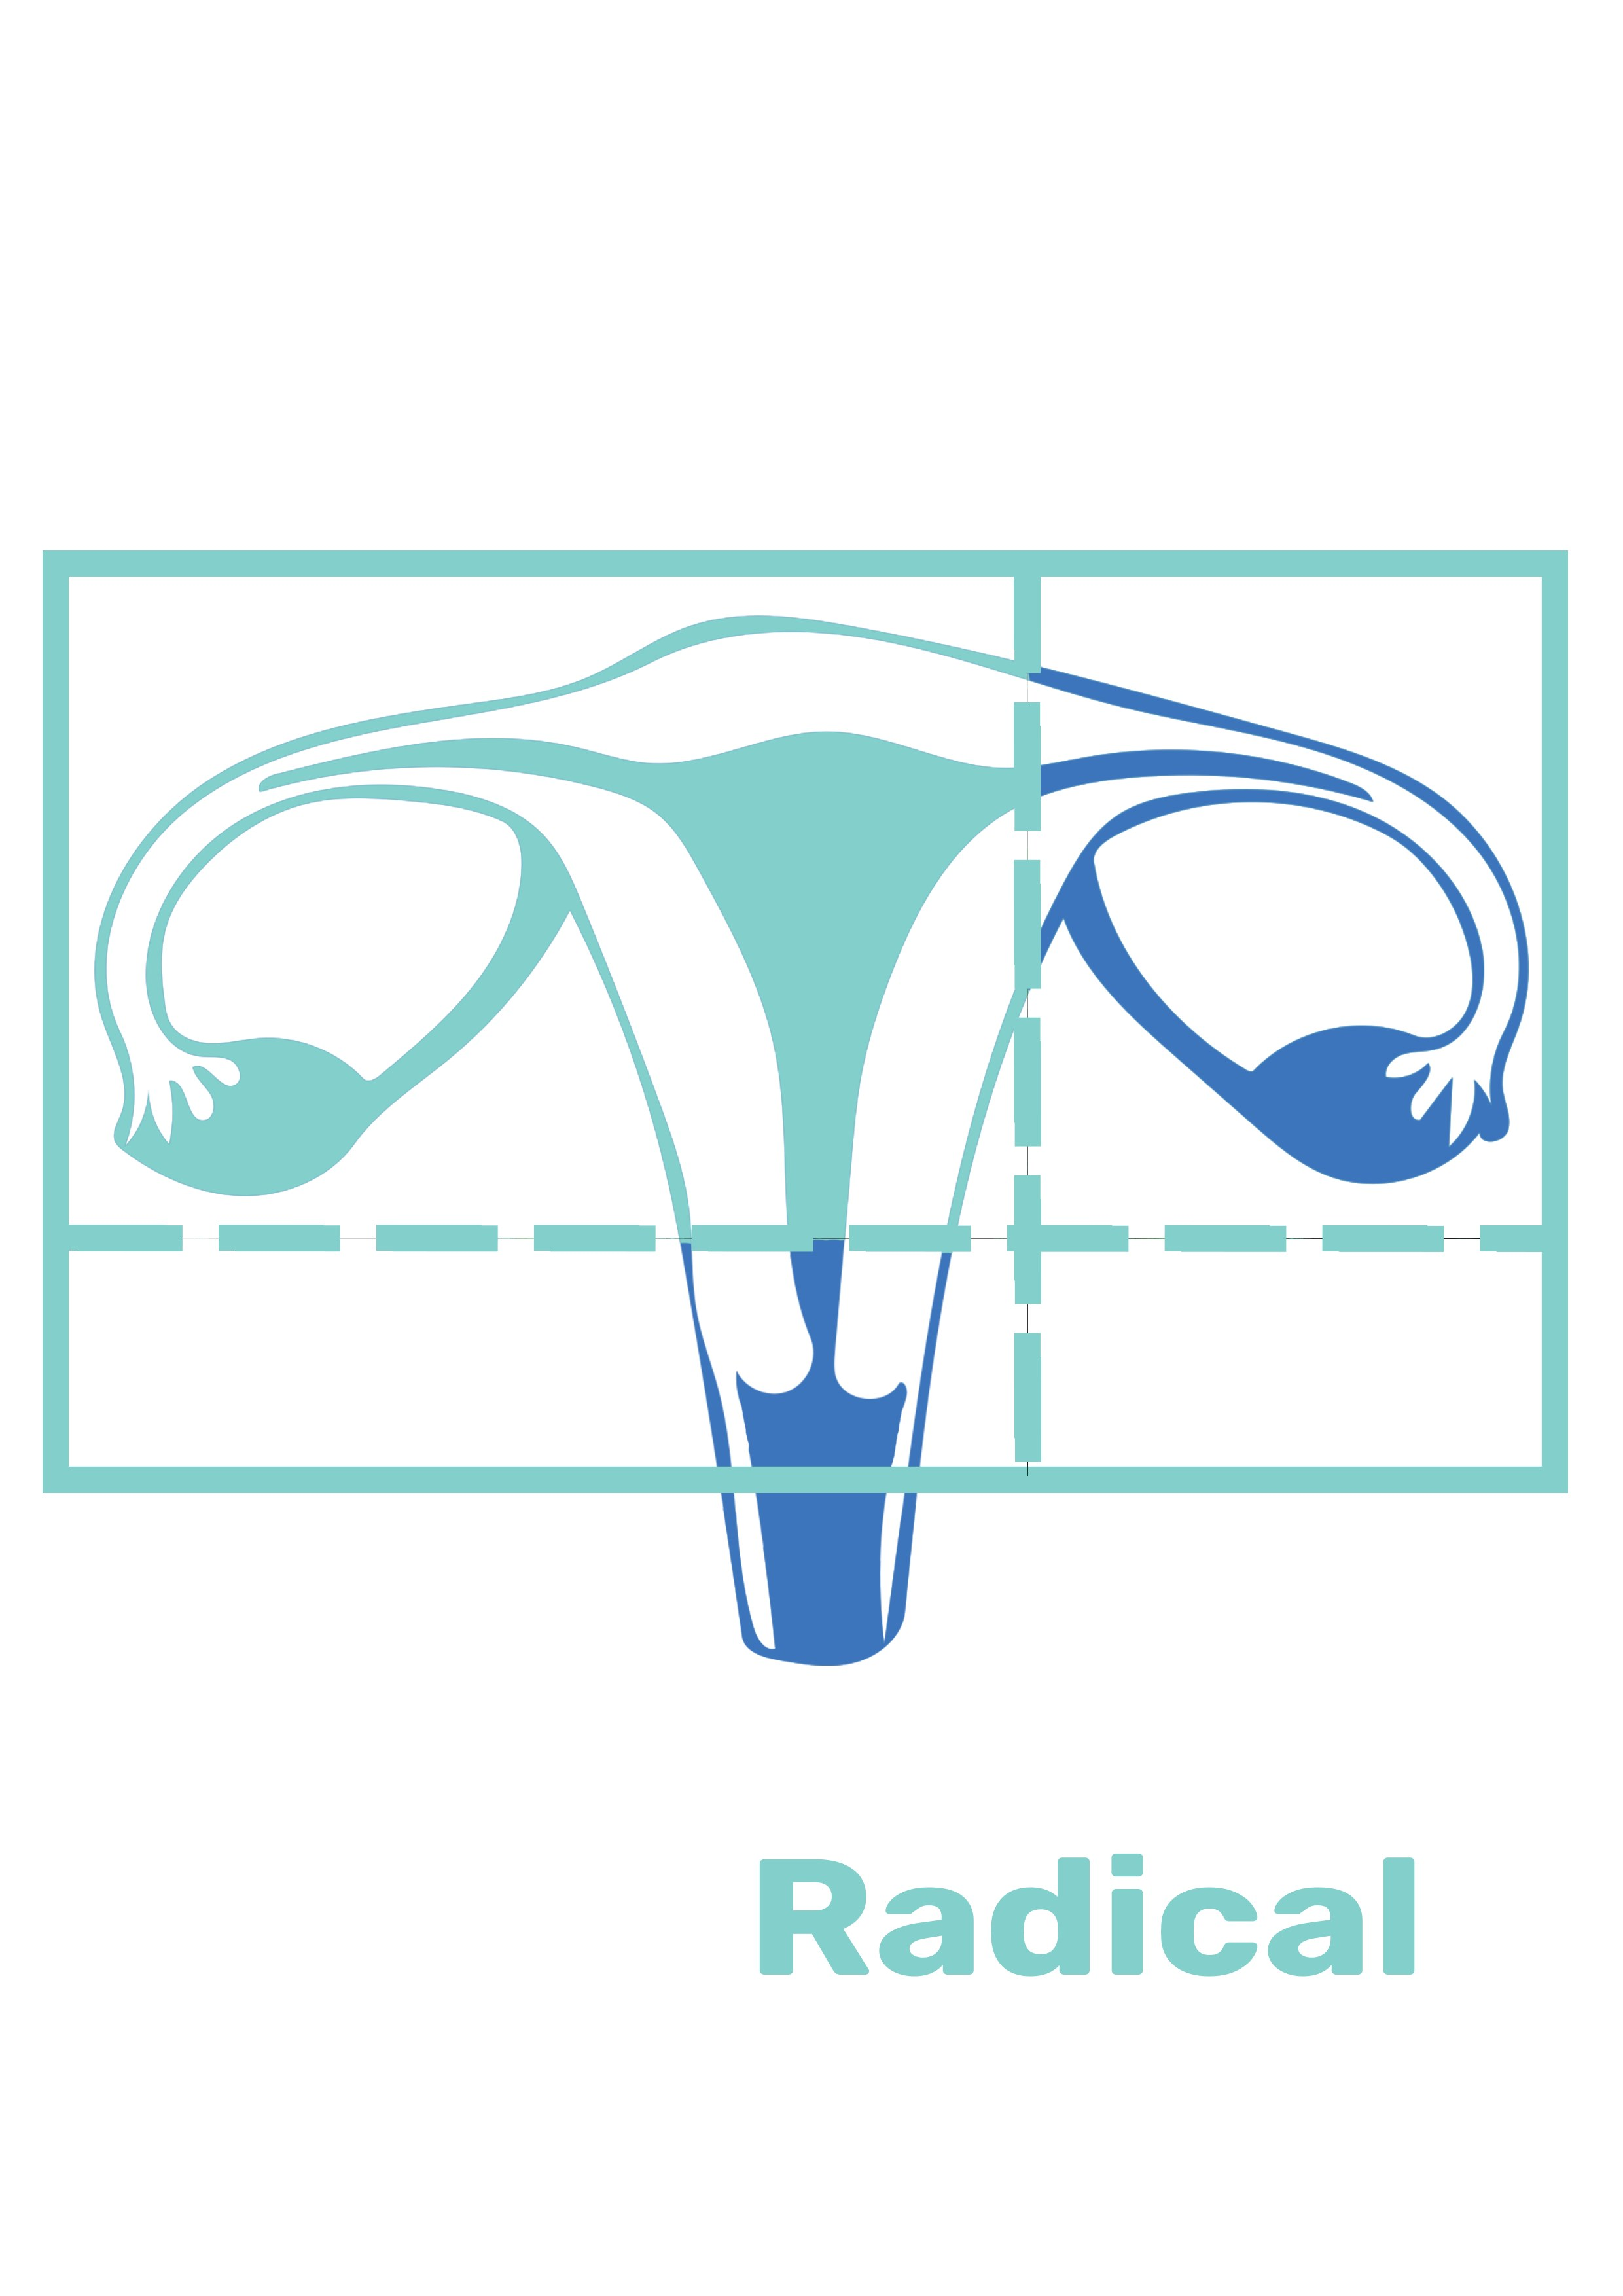
Radical hysterectomy with bilateral salpingo- oophorectomy includes removal of the:
- Uterus
- Cervix
- Fallopian tubes
- Ovaries
Surgeons who practice Gender Affirming Gonad Surgery may have special training in completing gonad surgery in preparation for or as a part of gender affirming genital surgeries that goes beyond a traditional surgery residency.
Incisions
- Abdominal incision goes through the muscle, tougher recovery in general
- Laparoscopic incisions are very small, and less invasive
  - A laparoscopic hysterectomy is much more common.
  - Tissue is removed via the front pelvic opening.

Preparing for surgery

Medical
Our primary medical provider should update our medical history and routine or prevention health exams that we need at our initial appointment about surgery.
A specialist may need to review our medical history or results from exams before we can be referred to surgery. Generally, any serious health conditions should be well controlled, and we should be working to modify risk factors within our control.
This is the ideal time to talk about ways to stop any smoking or vaping, nicotine intake, and supplement or substance use before surgery.
Additionally, surgeons may require site preparation before surgery that includes hair removal, physical therapy, dental exams, or weight gain/loss. Most insurances cover supportive programs that can help us take these steps for a safer surgery experience.

Mental Health
Our supporting mental health provider will discuss preparation, resources and information about mental health needs through surgery and recovery. Ongoing providers should be our first option for letters of support for surgery.
Generally, any mental health conditions should be well controlled, and we should be working to modify risk factors within our control. This is the ideal time to talk about ways to stop any smoking or vaping, nicotine use, and supplement or substance use before surgery.
Conversations with surgeons and other providers can also be triggering or require us to have exams, photos and letters that can trigger dysphoria later. It’s important for us to discuss the things that keep us safe and affirmed throughout the process.
Most insurances cover supportive programs that can help us take these steps for a safer surgery experience. This section will discuss and confirm mental health support through surgery.

Post- Op Depression
Many of us experience feelings of depression after surgery. This can come on a few hours, days or weeks after surgery and last just as long.
These feelings are not a reflection of how much we wanted or were ready to have surgery. They are a normal part of healing from surgery.
We may find ourselves feeling sad, lonely, frustrated, unmotivated, overwhelmed or strong changes in our mood throughout recovery.
In our research we may see folks dis- cussing depression after surgery and it’s impact a few different ways.
Things that bring this on for us may include:
- Support we have at home, be it not enough or too much.
- Hospital interactions, including our names or gender markers on paperwork or interactions with staff
- Results from surgery, including complications and revisions
- Missing out on routine activities, or not being able to return as we had planned to

Some of us may also be happy with our results, satisfied with our support, affirmed by our providers, and enjoying our time recovering from surgery, and still feel depressed.
That’s ok too.

Gender Affirming Hysterectomy Surgery Providers List

NYC Surgeons

Dr. Ruth Tessler NYU Langone
Tel: 212-545-5400
Procedures: Hysterectomy
Insurance: NY Medicaid, Private Plans

Dr. Zoe Rodriguez Mt. Sinai Center for Transgender Medicine and Surgery
Tel: 212-604-1730
275 7th Ave NY, NY 10011
Procedures: Hysterectomy
Insurance: NY Medicaid, Private Plans

Dr. Dorothy Min Downtown Women OBGYN
Tel: 212-966-7600
568 Broadway Suite 304 & 404 NY, NY
Procedures: Hysterectomy
Insurance: Private Plans

Dr. Siobhan Kehoe NYU Langone
Tel: 646-501-7870
Procedures: Hysterectomy
Insurance: NY Medicaid, Private Plans

Dr. Marina Stasenko NYU Langone
Tel: 646-501-7615
Procedures: Hysterectomy
Insurance: NY Medicaid, Private Plans

Dr. Timothy Ryntz Columbia University
Tel: 212-305-1107
51 W 51st St NY, NY 10019
Procedures: Hysterectomy
Insurance: NY Medicaid, Medicare, Private Plans

Community Resources
While talking to our care team we will confirm the logistics information for our surgery.
A number of these services may be covered by our insurance plan but require a request from providers before surgery.
Several surgeons also require patients have realistic expectations about the space we need to recover, time we need to restrict activity and support we will need after surgery.
TGNB community resources have provided care and support where insurance or other programs often cannot.
Transatlas.Callen-Lorde.org Community Provider directory

Trans Media Network great information but featured surgeons are paid advertisers
Transbucket.com make an account to see photos

Facebook Groups:
FTM & NB Hysterectomy Group
FTM/NB/GNC Hysterectomy
SRS / GRS / Breast Augmentation / Body Feminization Surgery / Transgender

Build A Relax-Kit
- Think of your 5 senses: touch, smell, sight, hearing and taste.
- Gather favorite things for any or all of these senses as you are able.
- Collect them in a bag, box or area that is easily accessible after surgery.
- Work these items into your aftercare plan or keep it around to use as needed.
Try and use these items when caring for yourself or if know that things may get overwhelming.
Some of your favorite frozen fruit in a water bottle can help stay hydrated, or favorite sent while completing wound care can help us stay grounded.

Questions for Consultation
A consultation is your chance to learn if a surgeon will meet your needs. This list is a starter guide for getting the most out of it! Ask Specific questions in order to get specific answers. You might not get all the answers in the initial consultation or need to ask every question, but these are all reasonable things to want to know before you commit to scheduling with the surgeon.
The Surgeon
- What training have you had in this surgery? What training did you have for offering this surgery to trans people?
- How many have you done total? How many do you perform in a year?
- How many patients are satisfied with the outcome? What kind of long term follow up do you do with patients who had this surgery?
- What percentage of your patients are trans? Are you involved with advocacy for the trans community?
Funding and Forms
- Will your office help fill out disability paperwork? Will you sign a letter to update my gender marker?
- Will the office negotiate directly with my insurance? When can I expect updates regarding the insurance negotiations? Who is my contact person? When will I know the out-of-pocket costs for using my insurance?
- Will the office help me with the appeal if surgery is denied by my insurance?
- If I am not using insurance to pay for the procedure, does the office accept financing plans? When are the payments due? Is the deposit to hold a surgery date refundable?
- Are there ways to lower the cost? Does the cost include hospital fees, pathology fees, anesthesia fees, all supplies, and all medications? Does the cost include revisions?
It is best to consult with more than one surgeon before making a decision. Bring a friend to take notes for you. Find pictures of ideal results to reference. Arrive early and expect the visit to run late.
The Surgery
- What is your most popular technique? Why? Do you offer other techniques? Are there techniques for this surgery you do not offer?
- How will the surgery impact sensation? When after surgery can I expect maximum sensation to return?
- How do you choose size and placement? Can I make specific requests?
- How long will I be under general anesthesia? Who is involved in the surgery? Who does what?
- Can I look at before and after pictures?
- Will staff use my preferred name and pronoun even if my documents are not updated?
Before Surgery
- How does my medical history impact this procedure? How far in advance should I quit smoking? Is there a minimum or maximum weight?
- Do you require a pre-op physical or bloodwork? Do you require that I stop hormones before surgery? Stop shaving the area or stop electrolysis?
- Any diet or lifestyle changes to speed healing?
After Surgery
1. What medications will I be prescribed? What dressing changes and rehab exercises will I need to do after surgery? How often? What scar care routine do you recommend?
2. How soon after surgery can I walk a mile? Take public transportation? Drive? Exercise? Drink Alcohol? Smoke pot? Have sex?
3. How long am I required to stay nearby after surgery? What appointments will we have after surgery? Do I need medical care at home to help with my recovery?
4. What complications can occur? How many of those complications heal on their own? How many people end up needing another surgery?
5. How soon after surgery will I see my final results? How much do complications impact the final result? What are my options if I don’t like the final result?

Notes:

