Genital Surgery

Phalloplasty Surgery
Phalloplasty uses a piece of (non-genital) skin that is fully removed (free flap) or partially removed (pedicled flap) and then re-attached to the genital area to create a penis.
Depending on the surgeon, phalloplasty can be completed in a 'single stage' or multiple stages. Regardless, if we are seeking an erectile device and/or testicular implants, we will need at least two surgeries, if not more.
Going through all of the surgeries involved with phalloplasty can take at least 1-2 years, but for many people it can take longer than that. We should also factor in time for replacing erectile devices every few years as well.
Phalloplasty can be combined with:
- Urethral lengthening
  - In order to stand to pee
  - Usually performed by a surgeon who has completed a reconstructive urology fellowship
- Vaginectomy
  - Removal of the vaginal opening
- Scrotoplasty
  - Creation of a scrotum or ballsack
- Glansplasty
  - Creation of a ridge or head of the penis
- Mons reduction
  - Pubic area lift and debulking
- Insertion of testicular implants and erectile device
Every body is different, as are the things that we would like to see after surgery. There are many options available for phalloplasty and the outcome for one person may be very different from another. Phalloplasty can take more than one surgery to achieve the desired outcome if you want implants or have complications.
1 - Musculocutaneous Latissimus Dorsi (MLD)
- Flap taken from the back
- Can potentially compromise aesthetics of chest and back, can pull nipple to the side
- Nerve hookup is possible
- UL is possible
- Inconspicuous (not easy to see) donor site when clothed
- May require use of split-thickness graft on back to cover donor site
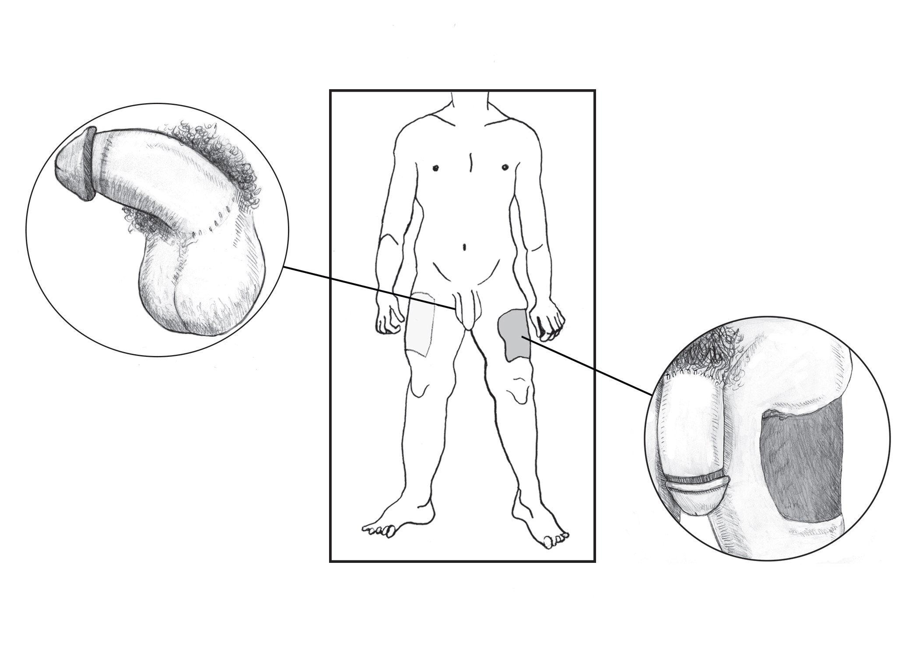
2 - Anterolateral Thigh Flap (ALT)
Taken from the outer (lateral) thigh
- Creates a penis that tends to be thicker (girthier)
  - because of the higher amounts of subcutaneous fat (fat that is beneath the skin)
- Girth can be reduced by liposuction and/or tissue excision
  - but may impact sensation
- A single nerve is connected
- Can be pedicled or non-pedicled
  - What does this mean?
    - Pedicled = major blood source to flap is not disconnected
    - Non-pedicled (aka 'free flap') = like RFF, flap is fully disconnected and re-attached by use of microsurgery
- Less apparent donor site
  - Can be hidden by long pants/shorts
- Higher risk of complications
  - with UL (Ascha et al., 2017)
- More flexibility with length
- More rigid than RFF phallus
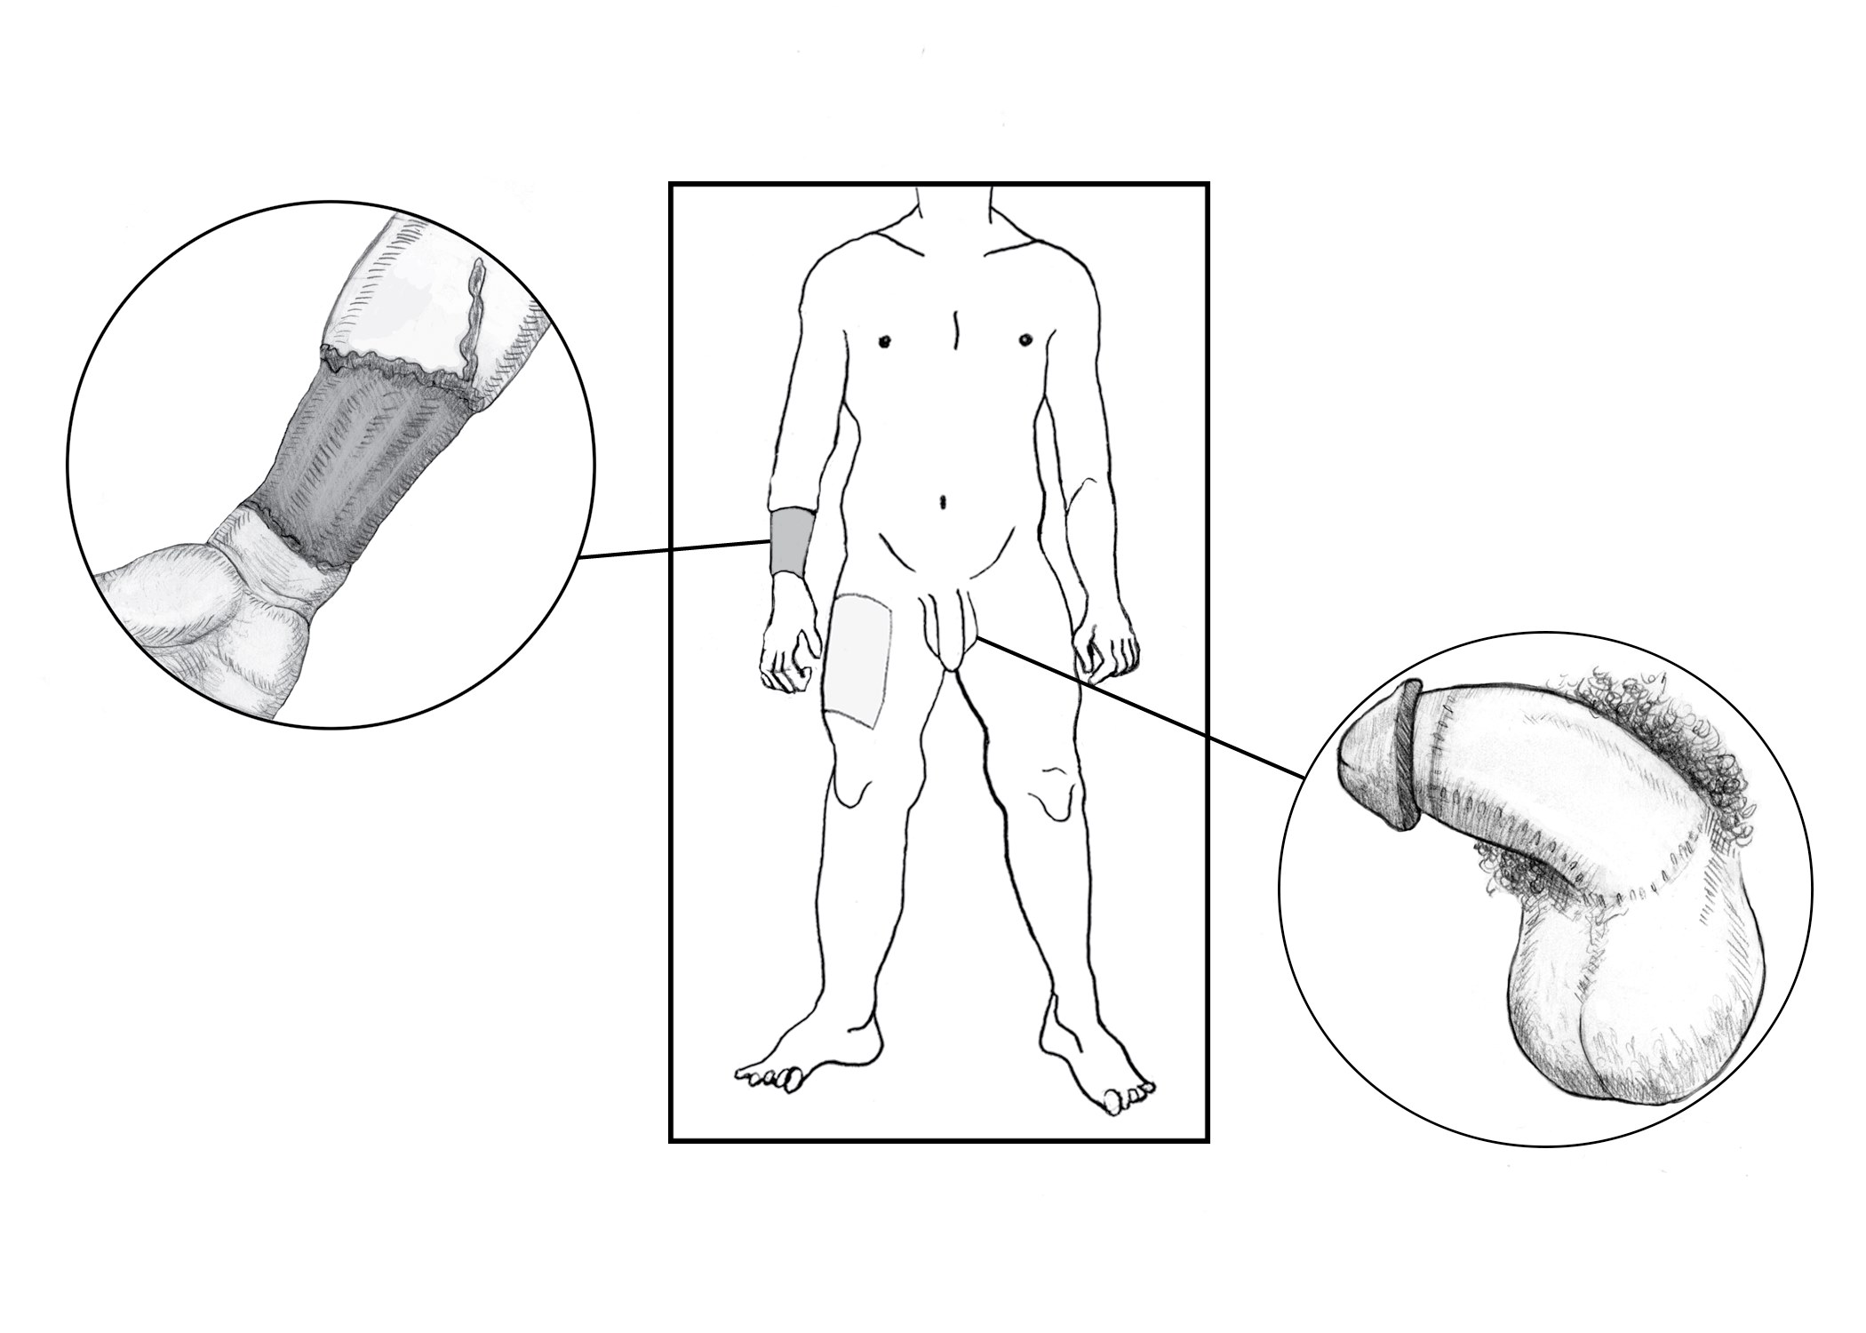
3 - Radial Forearm Flap (RFF)
Taken from the forearm (usually non- dominant arm); this donor site contains two nerves, and thinner skin than other donor sites
- Obvious scar left on forearm even after healing is complete
- Risk of long-term (chronic) swelling in hand and wrist
- May be limited in size (length and girth) of penis with a smaller/thinner forearm
- Higher chance of sensation (touch and erotic) because of two nerves in flap
- Erogenous and tactile sensation both possible (Ascha et al., 2017)
4 - Abdominal (Ab) Flap
- Flap taken from abdomen
- High risk of complications with UL
- Best for people who have lost weight and have extra skin
- Sensation less predictable – no nerve hookup
- Concealed donor site
- Does not require use of split thickness graft
Phalloplasty uses non-genital skin grafts from the body to create a new penis. Common sites used are forearm, thigh, and abdomen. Size is dependent on patient preference, donor site availability, and surgeon comfort; however, the penis does not grow/ shrink with arousal, and it is always the same size in your pants. Original tissues can be buried under the new penis, or left exposed.
Specialized plastic surgeons can use microsurgery during phalloplasty to connect blood supply and sensory nerves from the donor site (the forearm “RFF” or thigh “ALT”) to the blood supply and sensory nerves in existing genitals.
If this is successful, the full erotic sensation in the genitals will extend through the length of the new penis. Regardless, if the original genital tissue is contained within the new penis, it provides erotic sensation at the base.
Radial Forearm Flap (RFF)
Taken from the forearm (usually non- dominant arm); this donor site contains two nerves, and thinner skin than other donor sites
- Obvious scar left on forearm even after healing is complete
- Risk of long-term (chronic) swelling in hand and wrist
- May be limited in size (length and girth) of penis with a smaller/thinner forearm
- Higher chance of sensation (touch and erotic) because of two nerves in flap
- Erogenous and tactile sensation both possible (Ascha et al., 2017)
Anterolateral Thigh Flap (ALT)
Taken from the outer (lateral) thigh
- Creates a penis that tends to be thicker (girthier)
  - because of the higher amounts of subcutaneous fat (fat that is beneath the skin)
- Girth can be reduced by liposuction and/or tissue excision
  - but may impact sensation
- A single nerve is connected
- Can be pedicled or non-pedicled
  - What does this mean?
    - Pedicled = major blood source to flap is not disconnected
    - Non-pedicled (aka 'free flap') = like RFF, flap is fully disconnected and re-attached by use of microsurgery
- Less apparent donor site
  - Can be hidden by long pants/shorts
- Higher risk of complications
  - with UL (Ascha et al., 2017)
- More flexibility with length
- More rigid than RFF phallus
Abdominal (Ab) Flap
- Flap taken from abdomen
- High risk of complications with UL
- Best for people who have lost weight and have extra skin
- Sensation less predictable – no nerve hookup
- Concealed donor site
- Does not require use of split thickness graft
Musculocutaneous Latissimus Dorsi (MLD)
- Flap taken from the back
- Can potentially compromise aesthetics of chest and back, can pull nipple to the side
- Nerve hookup is possible
- UL is possible
- Inconspicuous (not easy to see) donor site when clothed
- May require use of split-thickness graft on back to cover donor site

Metoidioplasty Surgery
Metoidioplasty ('Meta'): frees the existing erectile tissue by cutting the tissue that holds it down against the body.
The penis might be enhanced by using nearby tissues to create more girth in “ring” and “centurion” methods, but generally length is dependent on growth from testosterone.
The penis can also loose length post op.
- No additional donor site, no large area of scarring
- Low risk of loss of sensation
- Often able to achieve unassisted erection
- Fewer stages
  - Generally only 1-2 surgeries
- May or may not be able to have penetrative sex depending on personal anatomy and growth from HRT (53% chance of being able to)
Metoidioplasty creates a small penis made out of the clitoris. It is usually done in one step, meaning one visit to the operating room (OR). The penis can become erect and stand up, but is usually between 1 and 2 inches in length. The penis size depends on the size of the clitoris before surgery, and how much it grows from T. Some of us use methods like pumping to try to get more growth.
This involves using a suction device so that the clitoris fills with blood, and the tissue slowly stretches to accommodate more blood flow. Not everyone is able to get permanent growth this way, and those that do usually pump every day, or multiple times a day. It is possible to hurt yourself with suction devices, so carefully read the directions of any pump and pay attention to pain and other signs of damage like bruising.
Every body is different, as are the things that we would like to see after surgery. There are many options available for Metoidioplasty surgery and the outcome for one person may be very different from another. Metoidioplasty can take more than one surgery to achieve the desired outcome if you want implants or have complications.
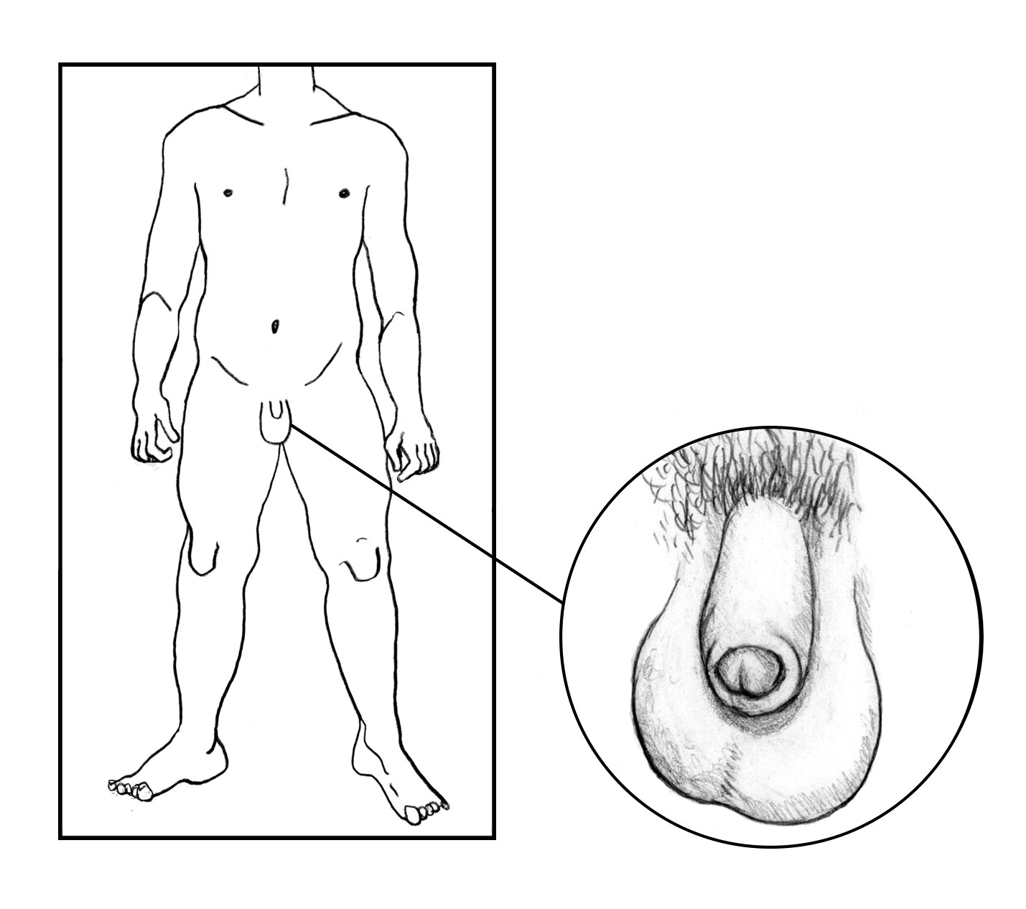
Meta can be combined with:
- Urethral Lengthening
  - In order to stand to pee - it can be difficult to clear the fly of the pants
  - Usually performed by a surgeon who has completed a reconstructive urology fellowship
- Vaginectomy
  - Removal of the vaginal opening
- Scrotoplasty
  - Creation of a scrotum or ballsack
  - Testicular implants can be inserted if desired
- Glansplasty
  - Creation of a ridge or head of the penis
- Mons reduction
  - Pubic area lift and debulking

Urethral Lengthening
Metoidioplasty and phalloplasty can both be done with or without urethral lengthening.
Urethral lengthening will make it so you can pee out of the tip of the penis.
Making the urethra longer will create the opportunity for more complications that can occur than if these surgeries are done without changing the urethra.
The most common complication is called a urethral fistula, where pee comes out of the body before the tip of the penis, like a pipe that has a leak.
Another complication is stricture, where the pee cannot get out fast enough, or eventually at all, because of narrowing from scar tissue.
Either of these complications could require more time with a catheter to collect urine or more surgeries in order to fix them.
Some people end up having years of surgery to fix issues that can happen with urethras.
It’s important to have a reconstructive urologist, or a specialist in building urethras, to be involved in the team doing surgery if you want to stand to pee, so that they have as many skills as possible to help take care of you if you encounter problems.

Vaginectomy & Scrotoplasty
Whether or not to get a vaginectomy, or removing and closing the front hole, is another big decision people make when getting lower surgery.
Getting a vaginectomy requires getting a hysterectomy as well.
The front hole can be removed without getting a metoidioplasty or phalloplasty, but may limit options for how those surgeries are done in the future.
Some people choose not to get vaginectomy so that they can continue to have front hole sex. If you want to continue to receive vaginal penetration after surgery, getting urethral lengthening could make this very difficult. The tissue added to extend the urethra to the front of the body can create scarring at the entrance of the vagina, tightening it a lot. Trying to lengthen a urethra while remaining able to receive front hole sex also raises the risk of fistulas and other problems that will need another surgery to fix. For this reason, many surgeons advise patients to choose one priority over the other. Trying to achieve both, at least in the short term, could easily result in having neither the ability to pee standing up or the ability to have front hole sex.
Some ways of creating a scrotum, or scrotoplasty, can also change this area of the body.
A simple (sometimes called “bifid”) scrotoplasty involves little movement of the skin, and silicone testicle implants, or balls, are inserted into the existing labia.
- Some people have issues with these testicles getting in the way while riding a bike, sitting, or having sex.
Having a complex (sometimes called “V-Y”) scrotoplasty means that the labia skin is moved more, requiring more downtime and healing as the incisions close. Usually, testicle implants are added after the complex scrotoplasty has healed.
- The goal of this is to create a more forward, hanging scrotum, which will not create issues with bike riding or other activities.
If you choose to keep your front hole, having a complex scrotoplasty should not interfere with having front hole sex once healing is complete, but does make the area look different.

Preparing for surgery

Medical
Our primary medical provider should update our medical history and routine or prevention health exams that we need at our initial appointment about surgery.
A specialist may need to review our medical history or results from exams before we can be referred to surgery.
Generally, any serious health conditions should be well controlled, and we should be working to modify risk factors within our control.
This is the ideal time to talk about ways to stop any smoking or vaping, nicotine intake, and supplement or substance use before surgery.
Additionally, surgeons may require site preparation before surgery that includes hair removal, physical therapy, pelvic exams, or weight gain/loss. Most insurances cover supportive programs that can help us take these steps for a safer surgery experience.

Electrolysis
Callen-Lorde recommends patients begin hair removal on skin being utilized for genital reconstruction as soon as possible while preparing for surgery to achieve total clearance after several hair growth cycles.
Hair removal can take over a calendar year, even if you are going to regular appointments every four to six weeks.
Consult your surgeon for guidance on what areas are being used, as techniques differ.
Your surgeon or PCP may be able to prescribe numbing cream to ease discomfort if needed. Being well hydrated before treatment also helps. We are not aware of any scientific evidence for claims that all hair can be removed during surgery.
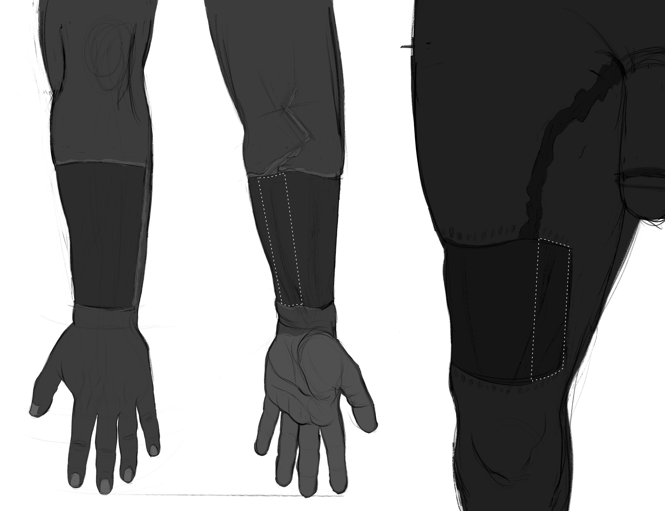
Hair removal can also be important aesthetically, if we do not want hair on our penis after surgery. However, we can have hair removal done on the OUTSIDE of our penis after surgery – or you can shave.
- Hair in the new urethra can cause urinary obstruction and hold onto debris, increase risk of infection and urinary dribbling (Zhang et al., 2016)
- May be able to get it covered by insurance with a letter of medical necessity from the surgeon
- Can also be done on the exterior of the penis post-op if hair removal was not completed pre-op, however it is more likely to be covered by insurance pre-op
- Hair removal cannot be done on the INSIDE of the penis post-op - any hair on the skin being used for the urethra MUST be removed as much as possible pre-op

Mental Health
Our supporting mental health provider will discuss preparation, resources and information about mental health needs through surgery and recovery. Ongoing providers should be our first option for letters of support for surgery.
Generally, any mental health conditions should be well controlled, and we should be working to modify risk factors within our control. This is the ideal time to talk about ways to stop any smoking or vaping, nicotine use, and supplement or substance use before surgery.
Conversations with surgeons and other providers can also be triggering or require us to have exams, photos and letters that can trigger dysphoria later. It’s important for us to discuss the things that keep us safe and affirmed throughout the process.
Most insurances cover supportive programs that can help us take these steps for a safer surgery experience. This section will discuss and confirm mental health support through surgery.

Sensation and Healing
Most of us stay in the hospital for about 1-3 days after surgery. We will likely wake up with a catheter in place.
The removal of the catheter will depend on the surgery we had and our recovery.
- If we get urethral lengthening, then we will have a catheter in for at least 2 weeks.
- If we do not get ureteral lengthening, then we will only have a catheter in for a few hours or until we can confirm we can pee on our own.
We may be able to climb one or two flights of stairs to get into our recovery space but should note that this will take much more energy and time to accomplish.
We can begin making adjustments to our bedroom, bathroom and kitchen for a more accessible recovery space at about 3 weeks before surgery. Moving the most frequently used items last and allowing time for us to get used to a different space set up if that's needed.
Recovery is not linear, we may need different support over time.
It’s best to make plans for support with things like grocery shopping, laundry and taking care of other humans or pets for about a month to six weeks after surgery.
Recovery time from surgery is generally 4-8 weeks with about 6-8 weeks off from work, school or taking care of other humans or pets. We will not be able to lift anything over 5-10 pounds for 6-8 weeks.

We should plan on needing someone to help with our activities of daily living for at least the first 1-2 weeks after surgery.

Our activities of daily living include things like
- Eating (or support with preparing meals)
- Bathing (or support with light cleaning)
- Dressing (or support with light laundry)
- Toileting (or restocking/refreshing supplies)
- Transferring (moving from sitting or standing or from room to room)
- Caring for our incisions (or help with picking up medication/supplies)
Public transit like the subway or the bus wont be accessible for a few weeks after surgery.
Some of us use a pillow to sit on or over our lap to help stay comfortable on short trips during our recovery period.
It is important to pay attention to the activity restrictions your surgeon will give you. Light activity, such as walking, is usually acceptable earlier on in your surgical recovery, but make sure to check in with your surgeon first before increasing your activity.
Some of the risks and complications that happen with metoidioplasty include:
- urethral complications like
  - scar tissue buildup
  - openings in the urethra
- wound openings
- tissue death
- numbness
- hypersensitivity
- swelling
Some people will need additional surgeries to fix complications.
Common reasons people seek revisions, or additional surgeries to correct issues, are aesthetic issues, urinary issues, infection, or erosion of the implants.

Gender Affirming Metoidioplasty Providers List

NYC Surgeons

Drs. Rachel Bluebond-Langner, Lee Zhao
NYU Langone
Tel: 646-501-4449
222 E 41st St NY, NY
Procedures: Vaginoplasty, Phalloplasty, Metoidioplasty
Insurance: Some NY Medicaid Plans, Medicare, Private Plans

Dr. David Michael Whitehead
Northwell Hospital
Tel: 516-497-7900
1991 Marcus Avenue, Suite 102
New Hyde Park, NY 11042
Procedures: Metoidioplasty
Insurance: NY Medicaid, Private Plans

Dr. Jonathan Keith
East Coast Plastic Surgery, NJ
Tel: 201-449-1000
Procedures: Vaginoplasty, Phalloplasty, Metoidioplasty
Insurance: Call for details

Rutgers Center for Transgender Health
Rutgers University, NJ Tel: 973-972-1129
Procedures: Vaginoplasty. Phalloplasty, Metoidioplasty
Insurance: NJ Medicaid Plans, Medicare, Private Plans

Community Resources
While talking to our care team we will confirm the logistics information for our surgery.
A number of these services may be covered by our insurance plan but require a request from providers before surgery.
Several surgeons also require patients have realistic expectations about the space we need to recover, time we need to restrict activity and support we will need after surgery.
TGNB community resources have provided care and support where insurance or other programs often cannot.
Transatlas.Callen-Lorde.org Community Provider directory

The Tool Shed peer support group for people interested in/post-op phalloplasty and metoidioplasty, 4th Wednesday of the month, 6:30-8 pm, email NYCtoolshed@gmail.com for more info

Trans Media Network great information but featured surgeons are paid advertisers
- Metoidioplasty.net
Transbucket.com make an account to see photos
Clubftm.com make an account to see photos

Facebook Groups:
- Metoidioplasty Discussion
- Metoidioplasty & Phalloplasty without Vaginectomy
Books:
Below the Belt: Genital Talk by Men of Trans Experience.
- https://transguys.com/book-reviews/below-the-belt
Hung Jury
- https://transguys.com/book-reviews/hung-jury-testimonies-of-genital-surgery-by-transsexual-men

Questions for Consultation
A consultation is your chance to learn if a surgeon will meet your needs. This list is a starter guide for getting the most out of it! Ask Specific questions in order to get specific answers. You might not get all the answers in the initial consultation or need to ask every question, but these are all reasonable things to want to know before you commit to scheduling with the surgeon.
The Surgeon
- What training have you had in this surgery? What training did you have for offering this surgery to trans people?
- How many have you done total? How many do you perform in a year?
- How many patients are satisfied with the outcome? What kind of long term follow up do you do with patients who had this surgery?
- What percentage of your patients are trans? Are you involved with advocacy for the trans community?
Funding and Forms
- Will your office help fill out disability paperwork? Will you sign a letter to update my gender marker?
- Will the office negotiate directly with my insurance? When can I expect updates regarding the insurance negotiations? Who is my contact person? When will I know the out-of-pocket costs for using my insurance?
- Will the office help me with the appeal if surgery is denied by my insurance?
- If I am not using insurance to pay for the procedure, does the office accept financing plans? When are the payments due? Is the deposit to hold a surgery date refundable?
- Are there ways to lower the cost? Does the cost include hospital fees, pathology fees, anesthesia fees, all supplies, and all medications? Does the cost include revisions?
It is best to consult with more than one surgeon before making a decision. Bring a friend to take notes for you. Find pictures of ideal results to reference. Arrive early and expect the visit to run late.
The Surgery
- What is your most popular technique? Why? Do you offer other techniques? Are there techniques for this surgery you do not offer?
- How will the surgery impact sensation? When after surgery can I expect maximum sensation to return?
- How do you choose size and placement? Can I make specific requests?
- How long will I be under general anesthesia? Who is involved in the surgery? Who does what?
- Can I look at before and after pictures?
- Will staff use my preferred name and pronoun even if my documents are not updated?
Before Surgery
- How does my medical history impact this procedure? How far in advance should I quit smoking? Is there a minimum or maximum weight?
- Do you require a pre-op physical or bloodwork? Do you require that I stop hormones before surgery? Stop shaving the area or stop electrolysis?
- Any diet or lifestyle changes to speed healing?
After Surgery
1. What medications will I be prescribed? What dressing changes and rehab exercises will I need to do after surgery? How often? What scar care routine do you recommend?
2. How soon after surgery can I walk a mile? Take public transportation? Drive? Exercise? Drink Alcohol? Smoke pot? Have sex?
3. How long am I required to stay nearby after surgery? What appointments will we have after surgery? Do I need medical care at home to help with my recovery?
4. What complications can occur? How many of those complications heal on their own? How many people end up needing another surgery?
5. How soon after surgery will I see my final results? How much do complications impact the final result? What are my options if I don’t like the final result?

Notes:

