Gender Affirming Facial Surgery

Facial Surgery
Gender Affirming Facial Surgery: Also known as ‘Facial Feminizing Surgery (FFS)’ or ‘Facial Masculinizing Surgery.’ These are a collection of procedures designed to change the bone structure of the face and reshape features that resulted from our first puberty.
Surgical Facial Procedures could include bringing the hairline further forward, shaving down or entirely recontouring the forehead and sinus area by cutting and repositioning bones (osteotomies), shaving the jaw line or reducing and repositioning of the jaw bone (a reduction or sliding genioplasty), lifting the upper lip, nose reconstruction or a ”nose job” (rhinoplasty), fat grafting, implants and tracheal shave (cricothyroid cartilage reduction).
The same procedures can be performed in reverse for masculinization.
Non-Surgical Facial Procedures could include the use of injectable or topical treatments to address scarring from shaving or previous facial procedures, hair growth or restoration or as an option for folks that cannot access surgical procedures at this time.
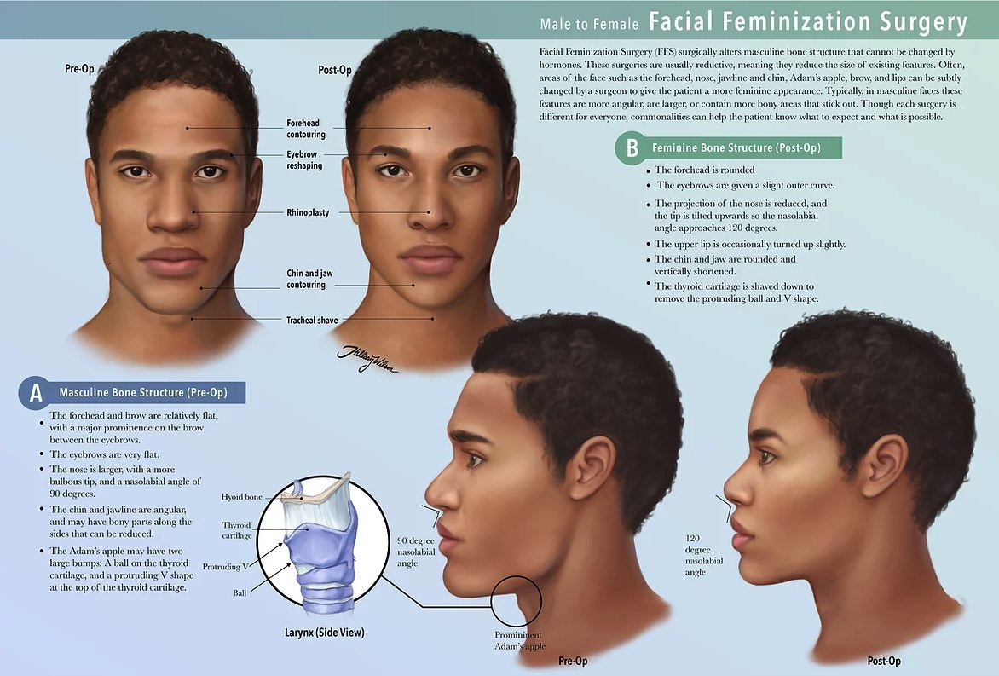
1 - https://www.hwilsonillustration.com/gender-affirming-surgery
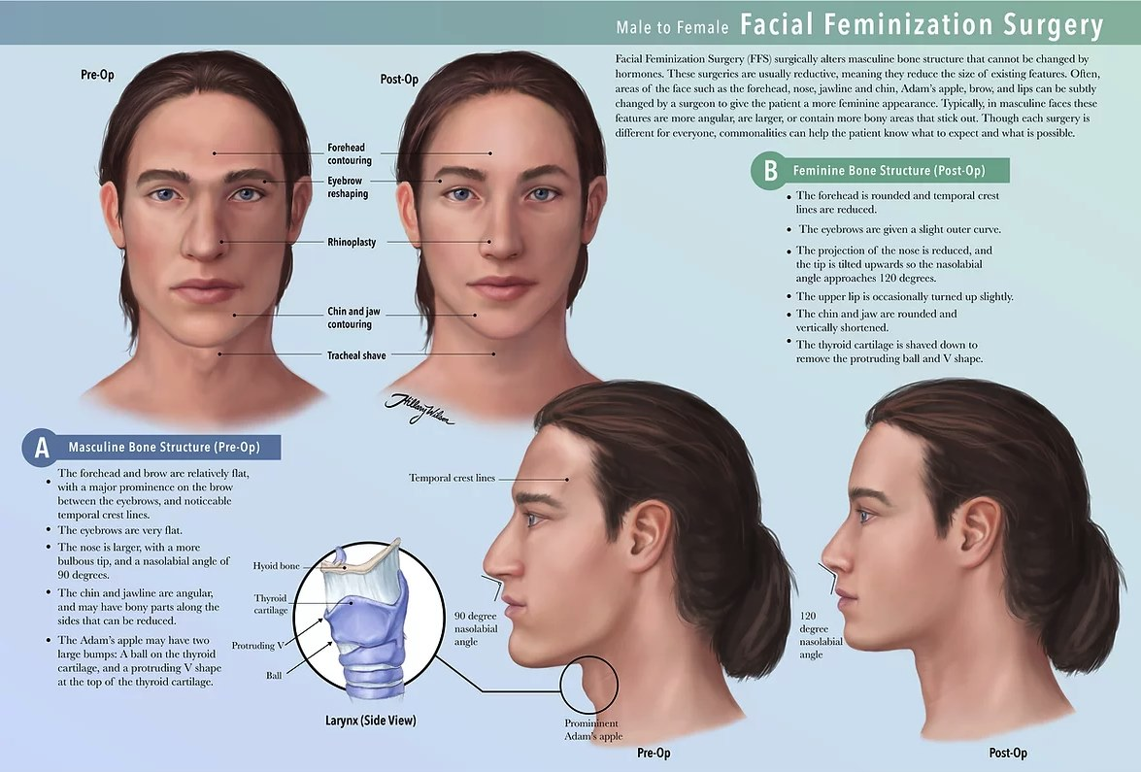
2 - https://www.hwilsonillustration.com/gender-affirming-surgery
Surgeons who practice Gender Affirming Facial Surgery often have special training in reconstructing facial features using bone grafting beyond a traditional plastic surgery residency.
Vocal surgery can raise the pitch of the voice, but it may also reduce vocal range.
Insurance and surgeons usually require Vocal Therapy before and after vocal surgery. Some of us may have significant results from vocal therapy alone and choose to not have surgery. Vocal surgeons usually have therapists that they refer patients to and are familiar with their requirements for preparing for surgery. These visits help us work with our vocal cords to change the vocal range of our voices when we speak. They also help prepare our bodies for recovery and the vocal therapy that is required to complete after surgery. Speech-Language Pathologists have special training to prevent vocal misuse and vocal damage.
Vocal surgery can raise the pitch of the voice, but it may also reduce vocal range. Total Vocal Rest for up to a few weeks is standard for recovery from these procedures. Complications can include having a raspy or strained voice after surgery.
Every body is different, as are the things that we would like to see after surgery. Terms like "masculine" and "feminine" can mean different things based on the time and place. Cultural differences in what "natural" means may also translate differently between us and our surgeons. Using words like soften, round, square, cinch, tighten, contour or flatten to describe the changes we would like to see after surgery can make our expectations clear.
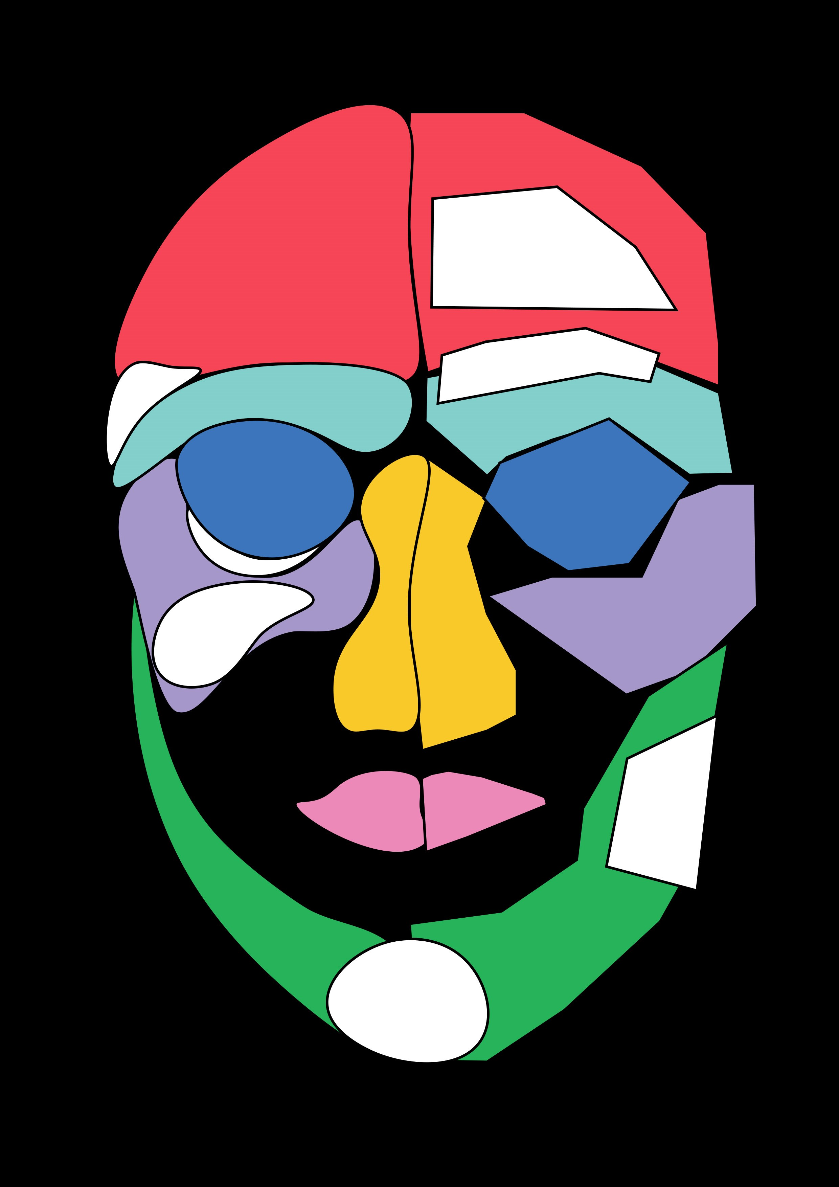
3 - Areas of the face that may be addressed during Gender Affirming Facial Surgery
Softened/rounded features are illustrated on the left side of the face
Pronounced/squared features are illustrated on the right side of the face
4 - Side view of the areas of the face that may be addressed during Gender Affirming Facial Surgery
Pronounced/squared features are illustrated on the left side
Softened/rounded features are illustrated on the right side
5 - Side view of the softened/rounded features
6 - Side view of the pronounced/squared features.
7 - Areas of the face that include bone surgery for softening or rounding facial features.
8 - Areas of the face that include bone surgery and tissue augmentation for softening or rounding facial features.
9 - Areas of the face that include bone surgery for squaring or making more pronounced facial features.
10 - Areas of the face that include bone surgery and tissue augmentation for squaring or making more pronounced facial features.
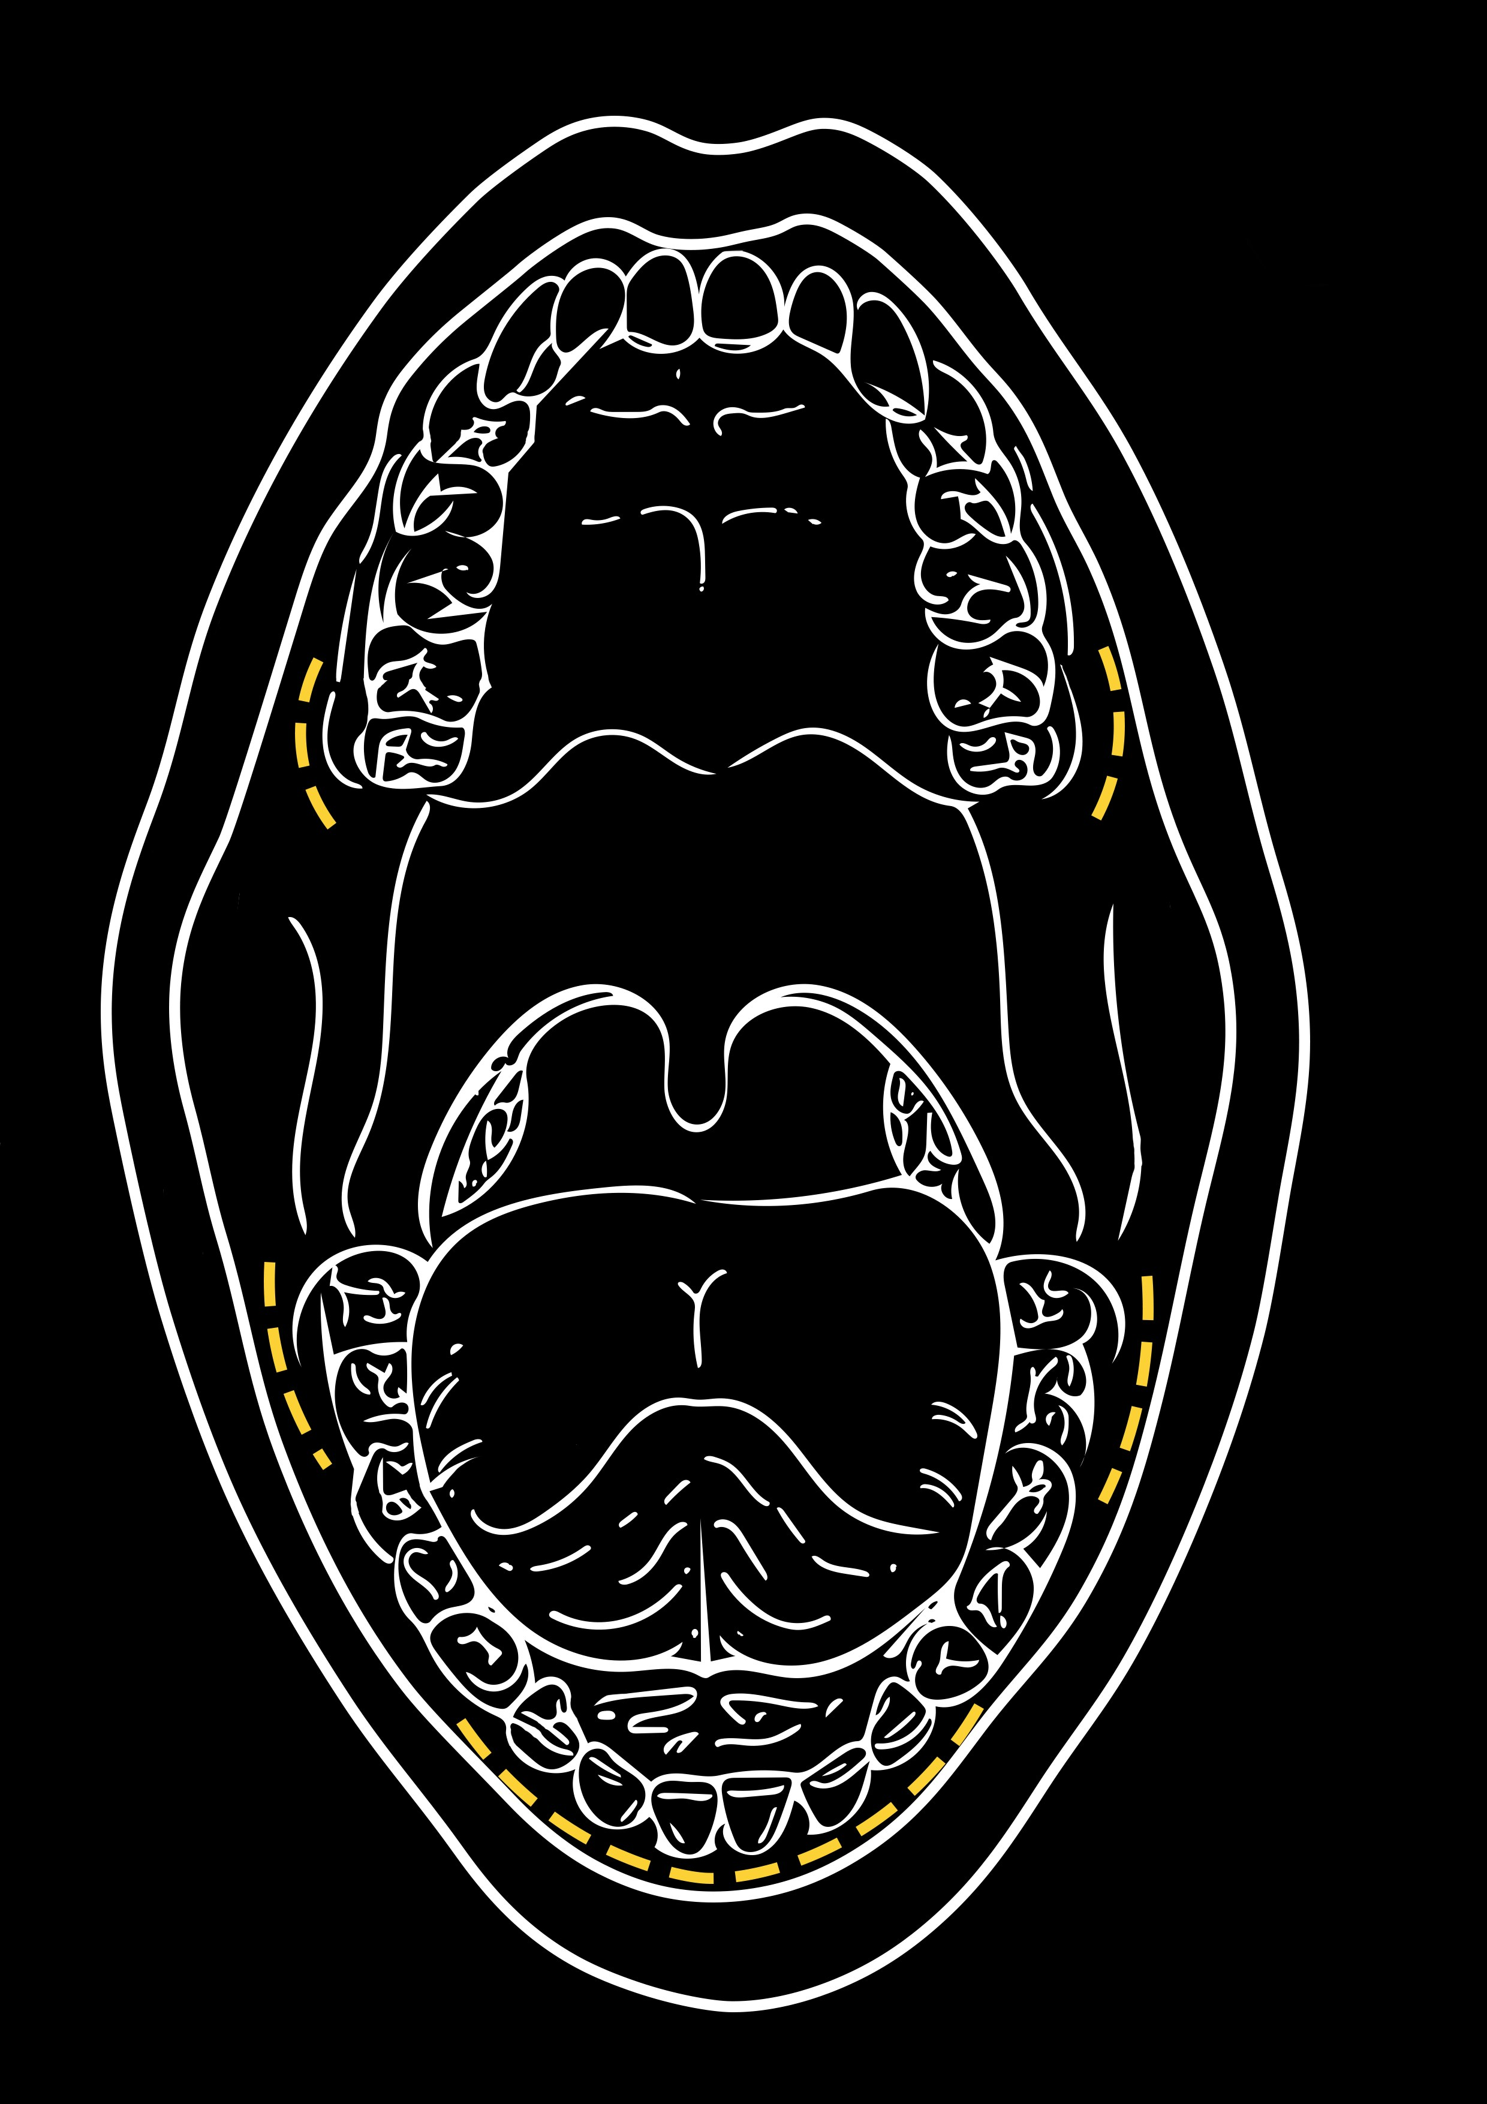
11 - Incisions inside the mouth are noted in yellow
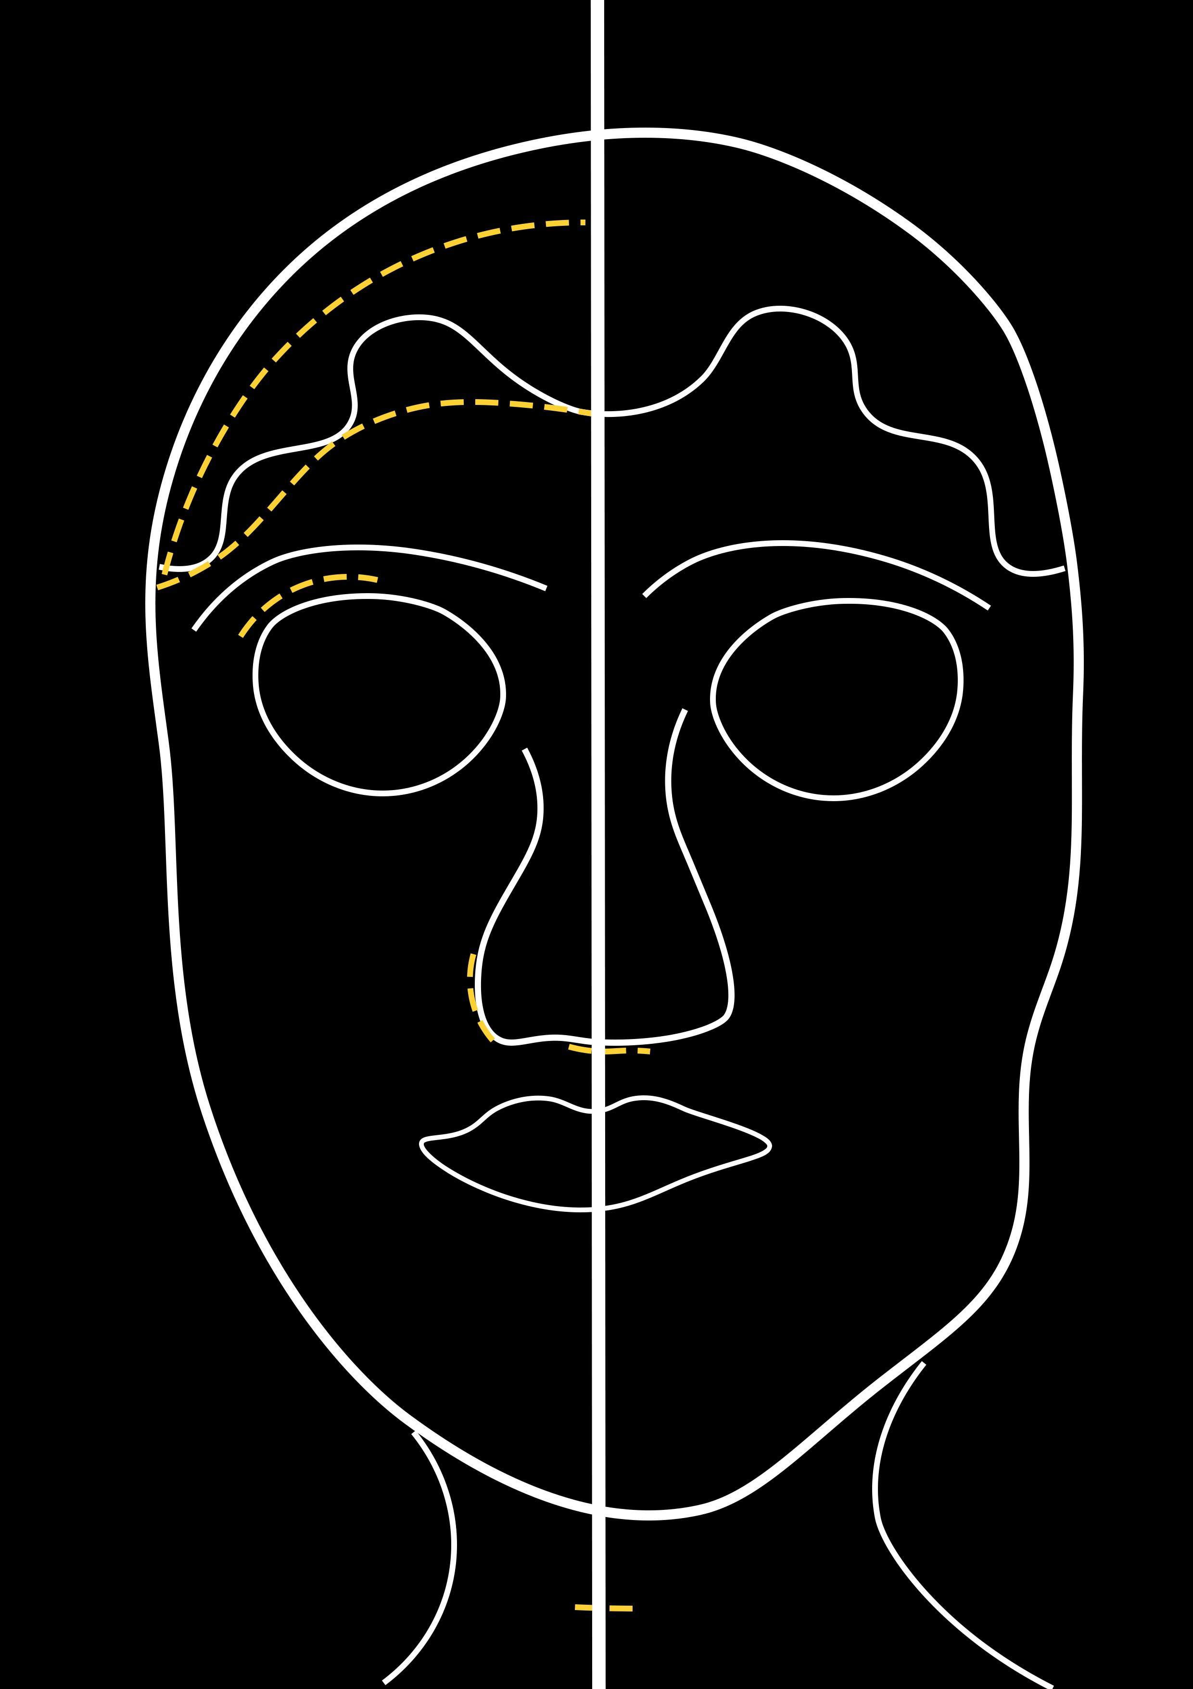
12 - Incisions for each procedure are noted in yellow

Preparing for surgery

Medical
Our primary medical provider should update our medical history and routine or prevention health exams that we need at our initial appointment about surgery.
A specialist may need to review our medical history or results from exams before we can be referred to surgery. Generally, any serious health conditions should be well controlled, and we should be working to modify risk factors within our control.
This is the ideal time to talk about ways to stop any smoking or vaping, nicotine intake, and supplement or substance use before surgery.
Additionally, surgeons may require site preparation before surgery that includes hair removal, physical therapy, dental exams, or weight gain/loss. Most insurances cover supportive programs that can help us take these steps for a safer surgery experience.

Mental Health
Our supporting mental health provider will discuss preparation, resources and information about mental health needs through surgery and recovery. Ongoing providers should be our first option for letters of support for surgery.
Generally, any mental health conditions should be well controlled, and we should be working to modify risk factors within our control. This is the ideal time to talk about ways to stop any smoking or vaping, nicotine use, and supplement or substance use before surgery.
Conversations with surgeons and other providers can also be triggering or require us to have exams, photos and letters that can trigger dysphoria later. It’s important for us to discuss the things that keep us safe and affirmed throughout the process.
Most insurances cover supportive programs that can help us take these steps for a safer surgery experience. This section will discuss and confirm mental health support through surgery.

Surgery
During our first surgical consult a surgeon will discuss the options for surgery that would most likely address our goals. They should talk to us about the parts of our face that will be changed, how they will change them, and how that will accomplish the goal we have.
Some surgeons like to use tools like 3D CT scans, MRIs or other imaging to help make an exact procedure plan. These scans help surgeons map out the nerves, tissue and bones across our face. They will see how thick our bones and soft tissue are so that they can recommend the procedures that safely fit the build of our face.
Dental and orthodontic care should all be resolved before having facial surgery. If there is a need for a root canal or other chances of bacteria in the mouth surgeons will generally ask us to take care of these before surgery. It's best to stop by for a routine check and cleaning at the start of planning facial surgery.
Please note that any reconstructive work to the jaw later on may impact the results of facial surgery.
Hairline procedures change the shape of our hairline, moving from an M shape to O shape. The incision will run across our new hair line and can be minimally visible with proper scar care. A few weeks after surgery the scar may also be covered with in-office hair grafting procedures.
Forehead procedures change the shape of our forehead, moving from a flatter shape to a rounded shape. Some surgeons may recommend changes to the sides (temples) of our forehead, making it narrower to match the shape of the forehead. Osteotomy procedures may remove a part of the bone and reshape it to make it smaller and sit further back. Reduction procedures may only “sand down” the bone (no bone breaking or screws). Surgeons will usually order a Facial CT scan to see the thickness of our bones to decide between reductions or set back procedures. Incisions for this are usually ear to ear and might go along the hairline (if we’re having hairline or scalp advancement procedures) or over the top of our head (think old school or over ear headphones).
Browbone procedures change the shape and volume of the sinus area (the space between our forehead and eyes). This makes it so we go from having a flat brow to having a curve or arch in the brow after surgery. Brow reduction surgery can include bone shaping surgery that shaves down the bone to match the roundness of the forehead and allow for a brow lift to curve the brow. Depending on our overall plan for surgery, the incisions for this procedure may run along the hairline, over the top of the head, or along the folds in the eyelids. CT scans completed before surgery help the surgeon identify the thickness of these bones and the location of the nerve bundles that we have above and below our eyes.
Nose procedures can change a few different parts of the nose. First, they may reduce the bump in the middle of our nose to make a smoother appearance. They can also change the tip of our nose to make it smaller and tilt up a bit more than before surgery. Lastly, surgeons might make our nostrils smaller to make our nose narrower. Incisions for these procedures may run along the sides of our nostrils and the bottom of our septum. Facial CT scans before surgery may identify conditions, like a deviated septum, that we’ve been living with and not been diagnosed with or found treatment for. Surgeons that have experience with reconstructive facial surgery may address these conditions as a part of our surgery.
Cheek procedures change the amount of light that bounces up into our eyes and the contours toward our jaw. Some procedures take tissue out to make our face longer and sculpt stronger contours along our face. Some surgeons graft fat from other parts of our body or insert implants to do the same. Incisions through the inside of our mouth (between the cheeks and teeth) allow for the surgeon to access the space they need and prevent visible scarring after surgery.
Lip procedures change the amount of space between our nose and our lips. Some surgeons trim the skin from just under our nose to make the space between our nose and lips smaller. The scar for this surgery is along the bottom of the nose and septum. Fat grafting or injectable fillers in the lips can accomplish the same goal for some folks. These are placed through the inside of the mouth and leave little to no scarring.
Jaw procedures change the angles and width of our jaw. Surgical procedures can reshape the bone to make for a longer, narrower face than before surgery. Some surgeons contour the angle of the bone so that they allow for our necks to appear longer and continue the soft curves from the brows to the chin. Surgeons access our jaw bones through the inside of our mouth and make incisions between our teeth and cheeks. Non-surgical options include injectables to “freeze” the muscles on the side of the jaw for some time.
Chin procedures change the shape and width of the chin to match the contours of the jaw and complete the bottom of a “heart shaped face.” Some chin surgeries reshape the bones to smooth the transition between the jaw and chin. Other surgeries take out a piece of bone from the front of our chin and slide the sides a bit further forward to make a narrower and longer chin. Some surgeons may recommend a chin implant to accomplish a similar goal.
Tracheal shave or thyroid cartilage procedures change the volume and appearance of the cartilage that some folks call the “Adam's apple.” Surgeons can make a small incision for this procedure under our chin (so it’s only visible from underneath) or in a natural fold of our neck.
Neck procedures may be included in surgery to tighten up the space created with bone reductions to the chin or jaw. We may have a drain after surgery to help keep the fluid from building up in this area.
Surgeons usually advise us on the amount of time we need to heal before it’s safe to begin treatments for hair grafting, injections, or other non-surgical facial procedures.
Expectations for recovery time and requirements depend on the parts of our face we decide to have surgery on. In general, any bone surgery is going to take about 6 weeks to heal from and we’ll have to limit activity for most of that time. The surgeries that require incisions in the mouth usually mean we’ll have a liquid, then soft-food diet for a couple weeks. These incisions can also make it so we can’t brush or floss our teeth, so surgeons give us mouthwash to use while our mouth heals. The mouth wash and limits to using our mouth are very important for preventing infection. Swelling and bruising can be intense after surgery. Some folks like wrapping up mirrors around home and unwrapping them throughout recovery (1 a week or so).

Gender Affirming Facial Surgery Providers List

NYC Surgeons
Dr. Eduardo Rodriguez
NYU Langone
Tel: 646-501-4481
Insurance: Amidacare Medicaid ONLY, Private Plans
Dr. Nicholas Bastidas
Northwell Health
1991 Marcus Ave Suite 102,
New Hyde Park, NY 11042
Tel: 516-497-7900
Dr. Andrew Lee
Montefiore Medical Center
3400 Bainbridge Avenue
Bronx, NY 10467-9014
Tel: 718-920-4646
Dr. Judy Washington-Lee
NYU Langone
Tel: 646-501-7886
Insurance: Amidacare, Private Plans
Dr. Lawrence Draper
Montefiore Medical Center
1250 Waters Place Tower Two
Bronx, NY 10461
Tel: 718-405-8333
Dr. Oren Tepper
Montefiore Medical Center
3400 Brainbridge Avenue
Bronx, NY 10467
Tel: 718-405-8333
Dr. Keith Belchman
Lennox Hill Hospital, Mount Sinai, NY Methodist
800A 5th Ave #300a,
New York, NY 10065
Tel: 212-427-3982
Dr. Richard Reish, Dr. Jerry Chang
Long Island Plastic Surgery Group
1111 Park Avenue Suite 1G
New York, NY 10128
Tel: (212) 879-8506
Dr. Jario A. Bastidas
Montefiore Medical Center
3332 Rochambeau Avenue
Bronx, NY 10467-2836
Tel: (888) 700-6623
Dr. Adam Daniel Perry
Northwell Health Physicians Partners Surgery Specialties at Bay Shore
250 East Main Street,
Bay Shore, NY 11706
Tel: 631-390-7100
Dr. Douglas Senderoff
461 Park Avenue South 7th Floor
New York, NY 10016
Tel: 212-481-3939
Dr. James Bradley
Private Practice/Northwell Health Physicians Partners Plastic Surgery
1991 Marcus Ave Lake Success NY 11042
Tel: 516-497-7912
Manhattan Office: 212-324-3777

NYC Facial Fillers & Hair Grafting (Non-Surgical only)
Dr. Alexes Hazen
110 E 66th St #6563, New York, NY 10065
Tel: (917) 301-6563

Voice Surgery and Tracheal Shave
Dr. Mark Courey
Center for Transgender Medicine and Surgery, Mount Sinai
Tel: 212-604-1730
Insurance: NY Medicaid Plans, Private Plans
Dr. Paul Kwak
NYU Langone
Tel: 646-754-1207
Insurance: NY Medicaid and Private Plans
Dr. Steven Rothstein
NYU Otolaryngology Associates
240 East 38th Street, 14th Floor
New York, NY 10016
Tel: 646-501-7889
Dr. Mark S. Persky
NYU Langone
160 East 34th Street, 7th Floor
New York, NY 10016
Tel: 212-731-6161
Dr. Michael Persky
NYU Langone Ambulatory Care Rengo Park
97-85 Queens Blvd, Queens NY
160 East 34th Street, 7th Floor
New York, NY 10016
Tel: 212-731-6644

Vocal Therapy
Grabschied Voice and Swallowing Center
Mount Sinai
Tel: 212-241-9425
https://www.mountsinai.org/locations/grabscheid-voice-swallowing-center/our-services/transgender-voice-feminization
Insurance: NY Medicaid Plans, Private Plans
Ry Pilchman
Prismatic Speech Services
Tel: 929-352-0559
ry@prismaticspeech.com
https://prismaticspeech.com/book-a-consultation/
Insurance: Contact insurance and provider for options
Christie Block, MA, MS CCC-SLP
New York Speech & Voice Lab
Tel: 347-677-3619
https://www.speechvoicelab.com
Insurance: Call office to inquire; offers a sliding scale

Community Resources
While talking to our care team we will confirm the logistics information for our surgery.
A number of these services may be covered by our insurance plan but require a request from providers before surgery.
Several surgeons also require patients have realistic expectations about the space we need to recover, time we need to restrict activity and support we will need after surgery.
TGNB community resources have provided care and support where insurance or other programs often cannot.
Callen-Lorde Surgery Patient Education Sessions by telephone appointment with a TGNB Surgery Doula. Please see a case manager or call one at (212) 271- 0000 to schedule.

Transatlas.Callen-Lorde.org Community Provider directory
Susans.org Facial Feminization Surgery Forum
Trans Media Network great information but featured surgeons are paid advertisers
hwilsonillustration.com/gender-affirming-surgery gender affirming surgery visual guide

Facebook Groups:
Top Surgery Support (Removal/Reduction)
Non-Binary Top Surgery
SRS / GRS / Breast Augmentation / Body Feminization Surgery / Transgender

Books:
Facial Feminization Surgery: A Guide for the Transgendered Woman Dr. Douglas Ousterhout
The Look of a Woman: Facial Feminization Surgery and the Aims of Trans-Medicine Eric Plemons

Questions for Consultation
A consultation is your chance to learn if a surgeon will meet your needs. This list is a starter guide for getting the most out of it! Ask Specific questions in order to get specific answers. You might not get all the answers in the initial consultation or need to ask every question, but these are all reasonable things to want to know before you commit to scheduling with the surgeon.
The Surgeon
- What training have you had in this surgery? What training did you have for offering this surgery to trans people?
- How many have you done total? How many do you perform in a year?
- How many patients are satisfied with the outcome? What kind of long term follow up do you do with patients who had this surgery?
- What percentage of your patients are trans? Are you involved with advocacy for the trans community?
Funding and Forms
- Will your office help fill out disability paperwork? Will you sign a letter to update my gender marker?
- Will the office negotiate directly with my insurance? When can I expect updates regarding the insurance negotiations? Who is my contact person? When will I know the out-of-pocket costs for using my insurance?
- Will the office help me with the appeal if surgery is denied by my insurance?
- If I am not using insurance to pay for the procedure, does the office accept financing plans? When are the payments due? Is the deposit to hold a surgery date refundable?
- Are there ways to lower the cost? Does the cost include hospital fees, pathology fees, anesthesia fees, all supplies, and all medications? Does the cost include revisions?
It is best to consult with more than one surgeon before making a decision. Bring a friend to take notes for you. Find pictures of ideal results to reference. Arrive early and expect the visit to run late.
The Surgery
- What is your most popular technique? Why? Do you offer other techniques? Are there techniques for this surgery you do not offer?
- How will the surgery impact sensation? When after surgery can I expect maximum sensation to return?
- How do you choose size and placement? Can I make specific requests?
- How long will I be under general anesthesia? Who is involved in the surgery? Who does what?
- Can I look at before and after pictures?
- Will staff use my preferred name and pronoun even if my documents are not updated?
Before Surgery
- How does my medical history impact this procedure? How far in advance should I quit smoking? Is there a minimum or maximum weight?
- Do you require a pre-op physical or bloodwork? Do you require that I stop hormones before surgery? Stop shaving the area or stop electrolysis?
- Any diet or lifestyle changes to speed healing?
After Surgery
1. What medications will I be prescribed? What dressing changes and rehab exercises will I need to do after surgery? How often? What scar care routine do you recommend?
2. How soon after surgery can I walk a mile? Take public transportation? Drive? Exercise? Drink Alcohol? Smoke pot? Have sex?
3. How long am I required to stay nearby after surgery? What appointments will we have after surgery? Do I need medical care at home to help with my recovery?
4. What complications can occur? How many of those complications heal on their own? How many people end up needing another surgery?
5. How soon after surgery will I see my final results? How much do complications impact the final result? What are my options if I don’t like the final result?

Notes:

